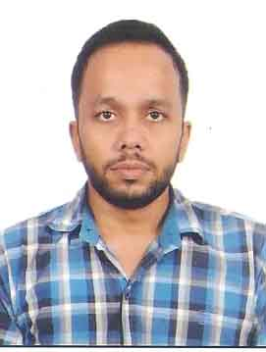
CURRICULUM VITAE

AZMAT

AZMAT.297553@2freemail.com
CAREER OBJECTIVE:
- To obtain a challenging job position in a reputed organization that will enhance my skills in terms of operational knowledge and help me to achieve learning experience along with my hard work and sincere efforts in relation towards the growth of the Organization.
- To accomplish my ambition of succeeding as a whole growth for the company and myself at personal level.

EXPERIENCE DETAILS:

(1) Did worked as a production manager from April 2008 to March 2010
COMPANY : DECORATIVE CRAFTS INTERNATIONAL. MORADABAD
DESIGNATION : Production Manager.

Main Responsibilities.
- To acquire knowledge from the very beginning of making raw products and take them out furnished in International Market.
- Handling projects from production to ship (Export).
- Conducted inspection on the damaged items to ensure that it in accordance to the clauses in the contract.
- Administered the facility and monitored the charges of the labor and the changes in the firm.
- Conducted inspection on the damaged items to ensure that it in accordance to the clauses in the contract.
- Prepared and submitting the reports of inspection as a quality control measure.

(2) Worked in COUNCIL OF SCIENTIFIC AND INDUSTRIAL RESEARCH (CSIR) in a Traditional Knowledge Digital Library (TKDL) - as a Administrative Assistant from May 2010 to April 2015.
Name of Organization | Council of Scientific and Industrial Research(CSIR) – A project named Traditional Knowledge Digital Library (TKDL) located at Morarji Desai National Institute of Yoga (MDNIY), 68 Ashok Road, New Delhi.
Designation | Administrative Assistant
Period of Service | May 2010 to April 2015 (5 years)
Nature of Duties | 1. Drafting & formatting letters, proposals &other documents  2. Handling day to day Administrative tasks.  3. Maintaining Files performing administrative tasks 4. Communication between Administration and TKDL Team.  5. Attending phone calls and answer them

STRENGTH

- Flexibility
- Punctuality
- Commitment
- Dedication
- Team work

EDUCATION QUALIFICATION
- Higher Secondary from U. P. Board in 2003
- Senior Secondary from U. P. Board in 2005
- B.Com from M. J. P. Rohilkhand University in 2008
- M.Com from M. J. P. Rohilkhand University in 2010

TECHNICAL SKILLS:
- Operating Systems: Windows 95, 2000, XP
- Basic: MS-Office, Internet
- Other: Good Typing Speed in English Language.

COMPUTER KNOWLEDGE
- Diploma in Computer Application.

PERSONAL INFORMATION

- Date of Birth : 27.10.1986
- Nationality : Indian
- Marital Status : Single
- Gender : Male
- Language Known : English, Hindi & Urdu.

I hereby declare that all the information given above is correct as per best of my knowledge.

