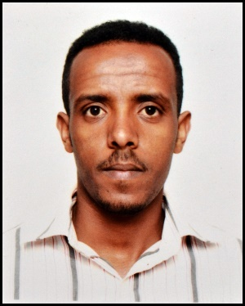
Abu Dhabi, United Arab Emirates
Grami.297618@2freemail.com
grmai
personal information |  | Sex: Male Nationality: Eritrean  Date of birth: 01/01/1991 Status : Single
objective |  | An enthusiastic computer engineer (Coen) graduate searching challenging position offering responsibility and opportunity for career growth.
Education |  | College Graduate in 2014(BSc. Degree in Computer Engineering), Eritrea  - From College of Eritrean Institute of Technology (E.I.T), Asmara, Eritrea.  - Papers are verified against the original University of Asmara Registrar, Asmara, Eritrea.
Experience |  | 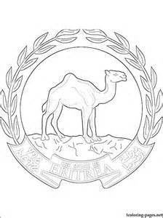  Ministry of Finance AUG-2014 TO SEP-2015 (Asmara, Eritrea)  Duties and Responsibilities:  Assigned to be the Computer engineer in charge of :  - Software, Hardware and NetworkMaintenance.  - Giving response to incoming Emails.  - Handling the IT stocks and as a Webmaster.
BC Maritime Services JAN-2011 TO MAR-2016(ASMARA, Eritrea)
Duties and Responsibilities:
Assigned to be the part-time IT Technician in charge of :
- Hardware, Network and Software Maintenance.
- Giving response to incoming Emails.
- Handling the IT stocks and as a Webmaster.

Hamasien restaurant may-2013 to oct-2013(ASMARA, Eritrea)
Duties and Responsibilities:
- Responsible to take orders and assist the cook to prepare food as per order of customers.
- Responsible in assisting the manager in preparing the menu card as well as price list.
- Providing effective supervision of all food and beverage services.
- Responsible to prepare recites and collect payments from the
customers.
- Implementing phone order delivery marketing plan to promote restaurant’s dishes to a wider range of people.

shewit asmara boutiquesep-2015to mar-2016(ASMARA, Eritrea)
Duties and Responsibilities:
- Provided customer services for up to twenty customers every day.
- Assisted customers in clothes and shoes determinations.
- Serve clothes and shoes to customers according to order.
- Recommended clothes and shoes to customers.
- Assisted the manager to clean and close the boutique after the
hours.
- Attended monthly staff meetings and training sessions.
personal skills |  | Good knowledge in :  - Scripting languages: Html, PHP, CSS and java script.  - Programming languages: Java, C, C++, Assembly, .NET and C#.  - Programming Concepts: Data structures, UML, RDBMS (MySQL), Oracle DB.  - Operating Systems: Windows XP/7/8/8.1/10, Ubuntu (Linux/Unix).
language |  | - Native in Tigrigna (Eritrean language).  - Fluency in English speaking and writing.
Declaration |  | I hereby declare that all the details furnished above are true to the best of my knowledge and belief.

