CURRICULUM VITAE
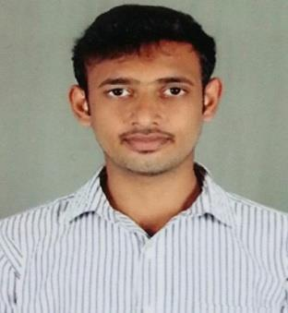

AHMAD
AHMAD.297676@2freemail.com

Objective

To have a growth oriented and challenging career, where I can contribute my knowledge and skills to the organization and enhance my experience through continuous learning and teamwork.

Academic Qualification

B.Tech Mechanical Engineering, in Hindustan University, Chennai.

Higher Secondary (2012) in Raj Matic Hr. Sec school, Mayiladuthurai, Tamilnadu. Secondary School (2010) in Raj Vid Matic Hr. Sec school, Kuttalam, Tamilnadu.

Software Proficiency

Software Known: Auto Cad,Catia,Ansyst, GD&T and DTP Works Office Suite: MS-Word, Excel & Power Point

Area of Interest

Manufacturing Technology Automobile Engineering

Designing Field

Achievements and Extra-Curricular Activities

Participated And Won Prizes In English Essay Competition At School Level. Participated And Won Prizes In Drawing Competition At School Level.

 |  | Mini Project
 | Project Area | : Manufacturing Technology
 | Project Title | : Two axis solar tracking with low energy
 | Project Role | : Team leader
 | Software used for Designing: Solid works
 | \ | Main Project
 | Project Area | : Manufacturing Technology
 | Project Title | : submerged arc welding carbon steel joints
 | Project Role | : Team leader

Industrial Visits

Dongsung Precision Company Pvt Ltd, Kancheepuram, Sriperumbudur.

 |  | Training
 | Implant Training:
 | Organization | : Dongsung Precision Company pvt Ltd
 |  | No-49,SengaduManavala Nagar,
 |  | Kancheepuram,
 |  | Sriperumbudur,602105.
 | Duration | : 1 Month
 | Knowledge Gained | : Learnt about various welding processes

Personal Trait

Creative And Logical

Problem Solving Ability

Co-Operative And Keen Observer Willingness to learn new things
Strength

Adaptability Hard working Honest
Good team player and positive attitude

Hobbies

- Surfing the internet

- Watching & playing cricket

- Reading books

- Listening music

- Playing volleyball

+

