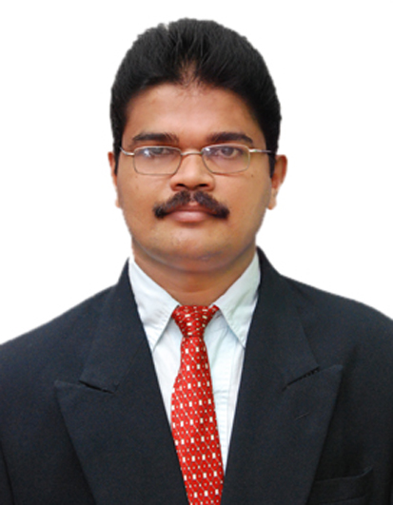CURRICULUM VITAE

SURESH
SURESH.298023@2freemail.com

ELECTRICAL FOREMAN

OBJECTIVE
To achieve a challenging position in any Industry that promotes my professional growth and prospects, in which my skills may be effectively utilized to contribute and enhance the company’s integrity, security and productivity.
Self Confidence, Intelligence with diligence, Team sprit and Leader ship quality. I trust HARDWORK and would prove as worthy asset of your concern and that your firm would provide me better a career.

ACADEMIC QUALIFICATION
- Diploma(Three Years) in Electrical & Electronics Engineering from Karnataka (Government) Polytechnic, Mangalore, India(Karnataka Govt. Technical Board of Education)
- P.U.C. (Higher Secondary/ 12th) from St. Aloysius College, Mangalore/ Karnataka State Higher Secondary Education Board, India.
- S.S.L.C. (10th) from Govt. Pre-University College, Benjanapadavu, Mangalore, India/Karnataka State Secondary Education Board Bangalore India.

EXPERIENCE PROFILE
- Electrical Foreman at SAS-AL-NAKHL air base project Abudhabi for Kharafi National Co LLC- overseeing Facility Management at Abu Dhabi,UAE since Mar 2015.
- 8 years of experience in the Engineering Institution (Colleges Campus) as an Electrical Foreman responsible to perform challenging technical work supervision and scheduling of maintenance and repair of a variety of electrical equipment in College Laboratory and Campus.
- 7 years of experience in Yenepoya wood industry solving electrical as well as mechanical problems of all the machineries & workshop supervisory experience.

SOFTWARE KNOWLEDGE

MS Office

KNOWLEDGGE, SKILLS & ABILITIES
- Thorough knowledge of the practices, methods, equipment, materials, and tools of the electrical trade.
- Good work in knowledge of Mechanical Equipment (Pumps & Motors)
- Thorough knowledge of the occupational hazards and safety precautions of the work.
- Ability to supervise the work of skilled workers.
- Considerable knowledge of the National Electrical Code for electrical installations.
- Ability to interpret and work from instructions, penciled plans and sketches, and blue prints.
- Ability to communicate and coordinate with superiors, subordinates, vendors and university personnel.
- Ability to estimate materials and labor costs.
- Skill in the use and care of all hand and shop tools and equipment of the electrician's trade.

CAREER HISTORY
PRESENT EMPLOYMENT:
SAS-AL-NAKHL air base project
Kharafi National Co. LLC, Abu Dhabi,
Designation: Electrical Foreman
From: 7th March 2015 till to date.
- Perform supervisory responsibilities for managing all aspects of the installation, maintenance, and repair of electrical power lines, electrical systems, fixtures, apparatus & appliances as well as mechanical equipment.
- Supervising electricians/contractors in carrying out the maintenance and installation of electrical and AC systems.
- Responsible for planning, scheduling, assigning, participating in, and inspecting the work of electricians.
- Manage PPM and demand works orders in an orderly and efficient way.
- Conducts periodic inspections and gives on-site supervision over hazardous or unusual work assignments; assures availability of equipment, materials, and supplies.
- Enforces safety regulations, rules, and working conditions.
- Train and instruct employees so they can perform their work safely. Know what personal protective equipment is needed for each task and how this equipment must be properly used, stored and maintained.
- Apply safe working practices at all times.
- Servicing & repairing of electrical panels, controlling units, generator, Motors and various other equipment.
- Read and understand basic drawings.
- Perform other duties that management may assign from time to time reasonably required.

PREVIOUS EMPLOYMENT:
- Canara Engineering College, Mangalore, India
Designation: Electrical Foreman (College Laboratory and Campus)
From Aug 2006 to Feb 2015
- Perform difficult technical work supervising and scheduling the maintenance and repair of a variety of electrical and mechanical equipment in College buildings including College Labs.
- Perform supervisory responsibilities for managing all aspects of the installation, maintenance, and repair of electrical power lines, electrical systems, fixtures, apparatus & appliances as well as mechanical equipment.
- Supervising electricians/contractors in carrying out the maintenance and installation of electrical and AC systems.
- Responsible for planning, scheduling, assigning, participating in, and inspecting the work of electricians.
- Conducts periodic inspections and gives on-site supervision over hazardous or unusual work assignments; assures availability of equipment, materials, and supplies.
- Supervises the operation of the electrical repair shop.
- Enforces safety regulations, rules, and working conditions.
- Servicing & repairing of electrical panels, controlling units, generator, Motors and various other equipments.
- Supervising & checking of load sharing of section of each building.
- Maintain records on electrical jobs and assign to appropriate personnel.
- Conducting various lab experiments on both AC & DC Electrical machines.
- Maintaining stock register for all electrical accessories.
- Supervise, Instruct and Guide the students in their respective jobs.
- Demonstrate operating of machines & lab experiments.
- Testing & servicing Lab equipments.
- Keeping the Laboratory in an ideal ship-shape condition.

- Yenepoya Processed Lumber (Unit Of Yenepoya Group Of Companies) Mangalore, India.
Designation: Industrial Maintainer-Electrical / Mechanical
From: May 1999 to July 2006
Responsibilities
- Supervising & checking of load sharing of all machineries.
- Servicing & repairing of electrical panels, machines, controlling units, generator, Motors and various other equipment.
- To carry out preventive, breakdown and planed overhaul of assigned equipment's such as medium voltage Switchgears, Transformers, Alternators, Motors and various other equipment.
- Weekly checking of all machineries, Transformers, generators, panels for smooth running of plant.
- Monthly report the working of plant & machineries to the main head office.
- Follow personal safety and protection procedures against possible hazards.
- Maintain cleanliness and safety of electrical equipment and devices at work site and ensure being operational.
- Carry out preventive maintenance as per the maintenance job plan and machine availability to minimize breakdown maintenance.
- Carry out breakdown maintenance and repairs when reported and requested to enable quick recovery of production.

I hereby declare that the above furnished details are true and correct to the best of my knowledge.

