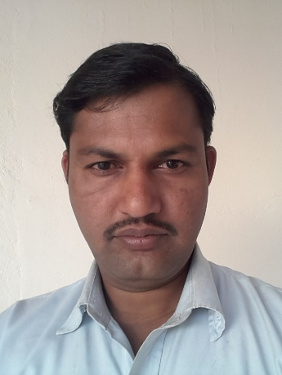
JAYESH
JAYESH.298086@2freemail.com

OBJECTIVE:-

- To become a successful marketing & sales executive or shipping in charge or store in charge or production manager or supervisor or office assistance.

ACADEMIC QUALIFICATIONS:

- Bachelor of Art’s with Geography in year 2000-01 from Mohanlal Sukhadiya
University, Udaipur.
- Master of Art’s with Political Science in year 2003-04 from Mohanlal Sukhadiya
University, Udaipur.
  - Post. Graduation Diploma in Computer Application with V.B 6.0 in year 2003-04 from
M.C.P.R.V. University, Bhopal (M.P.)

Computer Literacy:

- Good hold over MS-Office.
- Win 2000 Prof. ,Win XP Prof., Win 8 & Win 10
- Working knowledge of Tally 6.3.
- Excellent knowledge in MS-Excel & word with typing speed of approx 40 w.p.m
- Front end user in S.A.P. (Sales & Distribution Module).
- Working knowledge with focus (from 2010 to 2015).

Work Experience:

Al Sokhour Readimix Co. LLC.

One of the larger suppliers of Ready mix Concrete in Oman.

17th July 2010 to 14th December2015:-

Designation: Counter Sales & Dispatch in charge and plant supervisee.
Job Responsibility:

- Arranging for client requirement as and when required.
- Finalizing rates as per the company norms.
- Handling important projects.
- Coordinating for raw material & manpower as per requirement with the concerned department.
- Preparing for daily work schedule for distribution department as per the client
Requirement.
- Working and using FOCUS for delivery note and others.

Al Turki Cement Products L.L.C (Sohar - Oman)

One of the largest suppliers of Ready mix Concrete, Blocks and Crusher materials in Oman

11th May 2006 to 05 may 2010:

Designation: Sales & Dispatch Personnel.

Job Responsibility:

- Arranging for client requirement as and when required.
- Finalizing rates as per the company norms.
- Preparing monthly Sales & Production summary reports.
- Coordinating for raw material & manpower as per requirement with the concerned department.
- Preparing for daily work schedule for distribution department as per the client requirement.

Narayan Seva Sansthan, Udaipur (Raj.)

A Social Welfare Organization that collect donation for physically & mentally retarded people.

ONE YEAR

Designation: Computer cum Internet operator.

Job Responsibility:

- Receiving E-Mail from all concerns & forwarding it to head of department for further processing & receipt for the same.
- Sending E-Mail regarding prospectus of the organization & inviting them for donation.

Govt. Senior Secondary School, Rundera( Udaipur)

One of the best schools in town.

ONE YEAR

Designation: Computer faculty.

Job Responsibility:

- Used to teach & trains Students in basic operations of Computer.
- To trains in Microsoft word, Excel and PowerPoint
- Teach them basic knowledge of programming languages as C & C++.

Additional Skills:

- Good command over Arabic.
- Good communication & interpersonal skills.

Personal Details:

- Date of Birth 03rd July 1980.

- Marital Status Married

- Gender Male

- Nationality Indian

- Blood Group B+

(Issued from- Muscat, Sultanate of Oman)
- Driving license GCC valid Light Vehicle License
- Driving license Indian Govt. approved Light Vehicle License

Personal Traits:

To be one of the dedicated & important team member as well as important decision team maker of the organization

