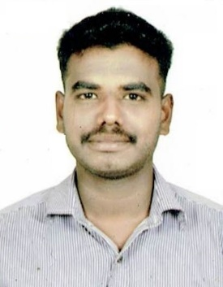
REGUNATH
REGUNATH.298368@2freemail.com

OBJECTIVE:

- Looking for exciting career opportunities in the field of Engineering, which proves my calibre.
- Active participation using skill and knowledge in the best possible manner with a Positive attitude to achieve organizational Looking goals and career growth along with professional growth.
Successfully accomplish

ACADAMIC PROFILE:

- Completed Bachelor of Mechanical Engineering in 2015 in Anna University at Tamilnadu.

- Completed Diploma in Mechanical Engineering in 2012 in DOTE at Tamilnadu.

TECHNICAL SKILLS :

- AUTOCAD - MECHANICAL
- Creo 2.0
- Solid works
- Ansys
PROFILE SUMMARY:

- Two years of experience as Quality Assurance engineer trainee in Automobile and Machining.

- Delivered quality controls and enhancements to proactively address problems and improved product quality, manufacturing flow, customer satisfaction and bottom-line results.
- Successfully, solved out many In-house issues and Line Issues with some exceptional technical ability and exemplary process knowledge
- Inventory Monitoring & Control.
- Quality Monitoring & Up gradation.
- Responsible for assured output from Fabrication shop

EMPLOYMENT HISTORY:

Company : RAJA CASTING AND ALLOY PVT LTD – Coimbatore

Designation : GRADUATE ENGINEER TRAINEE

Working period : FROM MAY 2015 to JULY 2017

ROLES AND RESPONSIBILITIES:

- Having through knowledge of making of pattern and also prepare the check sheet for full operation from moulding to melting process
- 2D drafting and detailing as per company standards and also create BOM
- Having operating knowledge of sand mixer machine
- Managed projects as engineering techniques and principles
- Study of customer Drawings and making development drawing for it.
- Ensuring the maximum output with power handling.
- Answering inquiries which involve preliminary calculation estimation release of tentative drawing mechanical design validations.
- Strong in instrument related inspection method for machining components.
- Measure product with Vernier, Micrometer and Gauges
- Trend chart preparation for rejection monthly wise
- 5S Improvements at inspection area
- Maintaining documents for ISO standards

PROJECT DETAILS:

- Design And Fabrication Of Vertical Axis Wind Turbine
(It mainly used for home appliance)
- Design And Simulation Of Sarrus Mechanism Using Solid Works
(It covert the rotary motion to linear motion)
PERSONALITY DETAILS:

- Excellent Presentation Skill and Communication Skills.
- Possess Good Attitude and Aptitude.
- Very Hardworking and A Confident Person.
- Dedicated, Patient and Energetic Person.

PERSONAL PROFILE:

- Date of Birth : 12/03/1993.
- Sex : Male.
- Marital Status : Single.
- Nationality : Indian.
- Languages known : Tamil, English.
- Visa Status : Visit Visa ( Valid Till 09th Dec 2017)

I hereby declare that the above mentioned details are true to the best of my Knowledge.

