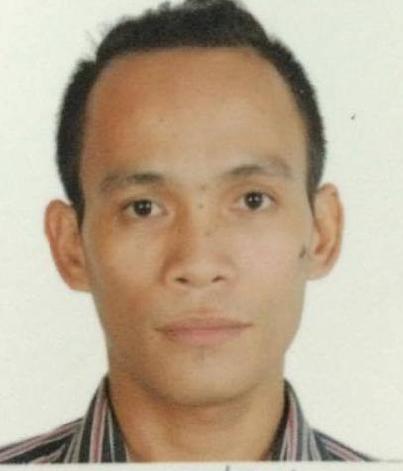
JOEMARIE
Joemarie.299048@2freemail.com

Objectives:
Seeking a fulfilling and competitive position where my extensive professional and practical experience will be fully utilized, and to join an organization where I can share my knowledge and abilities which in turn will develop me to become more professional in my chosen field.
- Proficient communication skills
- Computer literate
- Hardworking and energetic, flexible, adapt easily to change of environment and work schedule
- Eager to learn and able to coordinate to other people
- Able to work well others, planning, organizing and decision making skills.

Professional Qualifications:

College Graduate, with the degree of Bachelor of Science in Information Technology

Work Experiences:

- Program Assistant, in Betty Bantug Benitez Foundation, Inc. 2009 to present
- A part time job in Provincial Capitol as SK Local Legislative Staff 1, 2012-2013
- On-the-Job Training in Betty Bantug Benitez Foundation, Inc.
- 3rd District Office of the Congressman, data encoder
Educational Attainment:
Tertiary: 2014-2015 College Graduates
Central Philippines State University-Victorias City
Bachelor of Science in Information Technology
Vcitorias City, Negros Occidental

Secondary: 2008-2009
Victorias National High School
Brgy. V, Victorias City

Primary: 1997-1998
Daan Banwa Elementary School
Victorias City, Neg. Occ
Personal Data:

Age : 32
Date of Birth : June 5, 1984
Place of Birth : Victorias City, Negros Occidental
Religion : Roman Catholic

Affiliations

- BBBFI, Medical and Dental Mission Volunteer

Skills and Character Traits

- Speaks and Understand English and Tagalog
- Able to manipulate computer
- Can get along with other people
- Patience and hard working
- Respectful and dedicated to work

