Curriculum Vitae
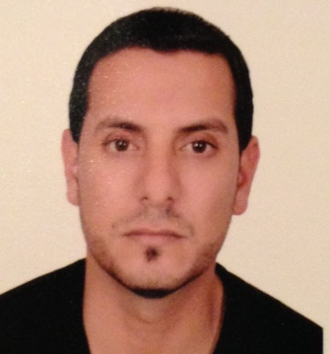
Nedal
Nedal.299276@2freemail.com

■Personal Information:

-Date of Birth: 22/7/1981

-Gender: Male

-Nationality: Jordanian

- Marital Status: Married

■Qualifications Summary:
ER nurse with the following experience and competencies:
- Six years of critical care experience – Intensive care in emergency room settings as RN and ER Management experience.(20/Jul/2008 ـــ 29/Jan/2015)
- Six years in ER Department as Associated Nurse(18/Feb/2003ـــ 19/Jul/2008)
- Effective communicator with patients and staff
- Computer literacy
■ Educational Qualifications &Courses:
- Bachelor’s degree in Nursing 2008 / Al-Zaytoonah Private University of Jordan
- Diploma degree in Nursing 2003 / Royal Medical Services College for Allied Health Profession
- BCLS Nov/2014 , Advanced Cardiac Life Support (ACLS) Dec/2014 .

■Licenses & Registrations :

-Jordan Nurses & Midwives Council.

-Ministry of Health Jordan License.
■ Objective Statement – Continuously enhance medical performance to improve healthcare provided, especially in complex medical situations and critical multi-system issues in the emergency room.
To become associated with a firm in which I may work to my highest potential and secure an appropriate position.

■Professional Experience:
-ER, Emergency Room Nurse( RN) King Hussein Medical City
{17/Jul/ 2011 –29/Jan/2015}.
- ER, Emergency Room Nurse( RN) Prince Hashem Bin Al-Hussein Military Hospital{20/Jul/2008 ـــ 16/Jul/2011}.

-Emergency Department associated nurse Field Medicine/Jordanian Royal Medical Services{18/Feb/2003 -19/Jul/ 2008}.

■ Core Responsibilities.
.Utilized the nursing processes; assessed, planned, provided and evaluated nursing care based on staff and patient interviews.
- Provided and managed goal-oriented patient care by utilizing established nursing processes and principles.
- Established nursing diagnoses and wrote out plan for treatment. Implemented cure and evaluated care.
- Demonstrated awareness of ongoing ER unit needs to provide other team members with leadership and direction for reaching optimal nursing care standards.
- Collaborated with other ER professionals to ensure effective patient care delivery – Identified patients’ conditions and addressed nursing care.
- Acted as a team member/leader to perform ER tasks.
- Experience in staff development, process improvement, and regulatory compliance in order to provide and perform superior patient care.
- Supervised the assigned staff – Was accountable for daily team performance.
- Assisted in the efficient operation of Emergency Room unit – Performed various medical assignments as required
. Continually looked for opportunities for professional development and improvement
■Skills:
  - Enthusiastic and self-starter
  - Working independently and within cross-functional teams
  - Very Good Communication skills, (verbal/written/listening)
  - Eagerness to learn and develop
  - Customer and Personal Service knowledge of principles and processes for providing customer and
- Personal services, this includes customer needs assessment, meeting quality standards for services, and evaluation of customer satisfaction

