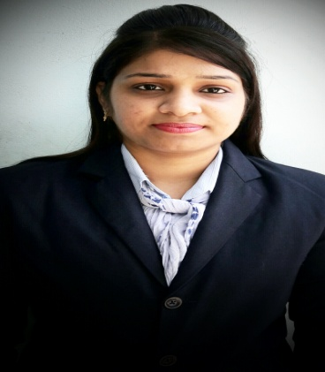
Anita
Anita.299582@2freemail.com

CARRIER OBJECTIVE

In corporate culture ready to accept challenges and utilizing my communication skills, smart working ability, fresh thoughts and assertive behavior, working to benefit the organization and contribute substantially to its development as a whole. Seeking an opportunity to work in challenging environment, learn new skills and enhance the same for company’s growth and development.

PROFESSIOANL PROFILE

-Over 9 months experience in teaching
-Proven track record in handling difficult situations and making students utilize and realize their full potential.
- Design, facilitate, and teach the computer instruction component.
-Initiate and implement systems, procedures
- Aspiring for an excellent carrier in Teaching

PROFESSIOANL EXPERIENCE

S.C.H. MEMORIAL PUBLIC SCHOOL JULY 2015 TO MARCH2016

COMPUTER TEACHER

-Design, facilitate, and teach the computer instruction component.
-Prepare execute lesson plans, assigning tasks, and evaluating student work and progress.
-Develop course syllabus, assess, supervise, and motivate high school students.
--Promote safe, effective, and ethical learning environment.
-Conduct group training sessions.
-Teaching students with Visual aids for better understanding.

EDUCATION AND PROFESSIONAL DEVELEOPMENT

Degree | Board/University | SCHOOL/  INSTITUTE | YEAR | Percentage  /Division
MCA | PTU | KCL-IMT  PUNJAB(INDIA) | 2013-  2015 | 77.85% (1st division)
B.sc IT | GNDU | DAV College  PUNJAB(INDIA) | 2009- 2013 | 58.64% (2nd division)
12th | PSEB | Govt. Sr. Sec .School PUNJAB(INDIA) | 2009 | 66.22% (1st division)
10th | PSEB | Govt. Sr. Sec. School PUNJAB(INDIA) | 2006 | 62.70% (1st division)

CERTIFICATIONS

- Web Programming in PHP & MYSQL
- International English Language Testing System(IELTS) in 2009 with 5 bands
- International English Language Testing System(IELTS) in 2011 with 5.5 bands

SPECIALIZATION AND TECHNICAL SKILLS

- Basic knowledge of MS Office :MS Word, MS Excel, MS PowerPoint
- Web Technologies : HTML, PHP
- Programming Languages : C, C++,Data Structure
- Familiar with OS Windows (XP, Vista/Window7,8)
- Proficiency with Internet.
- Miscellaneous : Software Engineering, DBA, Embedded Systems, Advanced Operating System, Computer Graphics, Network Security, Data Mining.

PERSONAL QUALITIES AND STRENGTHS

- Confident
- Time management skills
- Excellent written & oral communication
- Excellent presentation skills
- Able to do work individually as well as in team.
- Willing to learn and hardworking.
- Good analytical skills and logical skills
- Adaptability to changing the environment and trends.

PROJECT DEVELOPED

Name of project:-Crime File System
Place:-Sakaar Micro solutions Pvt.Ltd Defence colony Jalandhar(INDIA)
Technology Used:-PHP
Year of Development:-2015

Academic Achievements

- First prize in On the Spot presentation

- First prize in AD-MAD-SHOW

- Second Prize in Web Development

LANGUAGE PROFICIENCY

Excellent command over spoken and written English

Other languages- Hindi and Punjabi

Declaration: I hereby declare that all the information that I have given here is true according to the attested testimonials. If given a chance to me, I will put in my best efforts to prove myself worthy in the eyes of my employers.

