Architect with comprehensive experience preparing specifications for the completion of superior commercial, public, educational and residential buildings.
Proven ability to prepare detailed drawings of architectural designs which include plans, elevations, and sections.
Highly experienced in deleveraging technical expertise in AutoCAD, Photoshop CS, and Google Sketch Up to develop presentations, renderings, and 3-D illustrations.
Skilled in applying creativity to create highly appealing, exciting, and interesting concept and designs that engage and evoke emotion.

EDUCATION.

University Visveswaraya College of Engineering (UVCE)
Bangalore University, Bangalore.
Bachelor of Architecture (2014)

SOFTWARE SKILLS

- Auto-cad 2d
- Google Sketch-up
- Revit
- Archi-CAD (learning)
- Primavera (learning)
- Adobe Photoshop
- V-ray rendering
- MS Office (suite)

RESUME
ASIM ASIM.299752@2freemail.com

CORE COMPETENCIES.
- Architectural Design.
- Commercial, Educational & Residential Buildings.
- Construction documents.
- Client satisfaction.
- Graphics presentation & layouts.
- Site planning.

PROFESSIONAL EXPERIENCE.
CRESCO DESIGN STUDIO PVT. LTD
(Sep 2013 – Jan 2014)
Intern Architect.
Developed schematic design presentation materials (diagrams, rendering, and floor plans) and collaborated with marketing department to produce advertising collateral and packets for client review. Contacted vendors for material samples to create mock ups and 3-D material boards for senior designers.
During this period I have worked on the following projects.
Residential (Old Age home), Chennai.
Ravi Kumar residence, Bangalore.
Yellesh babu residence, Bangalore.
Santosh residence, Bangalore.

ABDUL AZEEZ ARCHITECTS (Mar 2014 – July 2014)
Intern Architect.
Undergone through various steps of design process starting from site surveying to 3D presentations, interior design, sanction drawing and working drawing, learned about office management.
During this period I have worked on the following projects.
Mr. Ameen residence, Bangalore.
Interior design of IQRA INTL’ school, Bangalore.
University campus building for MSHAM educational & charitable trust, Bangalore.
Residential apartments for Fantasy builders.
@ BTM layout, Bangalore.
@ BASAPURA, Bangalore.

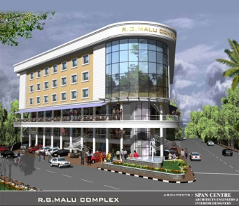

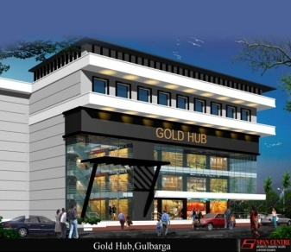

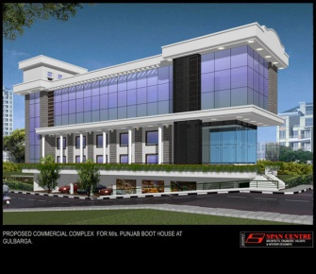

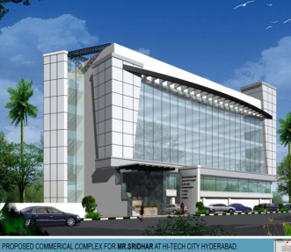

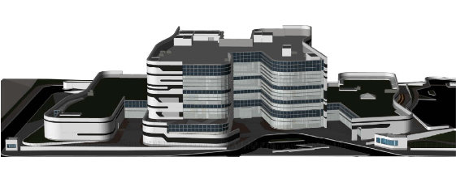

NATIONAL CENTER
FOR EDUCATIONAL
INFORMATION

SPAN DESIGN AND DEVELOPMENT (P) LTD.
(July 2014 – May 2015)
Junior Architect.

- Coordinate with off-site project teams and communicates project status to management and on-site staff.
- Was in charge of code quality assurance and code review as per organizational standards.
- Devise various architectural design and codes for projects to be implemented.
- Involved in requirement gathering and working with design team to implement various customs controls.
- Train new staff on the various design process.
- Lead in the creation of user-friendly interfaces and broachers for all design developed.
- Act as a liaison between management and development staff at the organization.
- Respond appropriately to any queries or issues that the end user of the application or design may not address.

During this period I have worked on following projects.
Commercial complex Gold hub @ Gulbarga
Proposed commercial complex for Mr. Sridhar @ Hyderabad
Commercial complex for Punjab Boot House @ Gulbarga
Under design process,
R.G Malu complex @ Bangalore
Residence for Mr. Muniraj @ Bangalore

Gulf Experience
(Aug 2015 – till date)
Architect Engineer.

PROJECT INFORMATION.
Project: National center for educational information.
Location: Ministry of Education, Riyadh KSA.
Client: Ministry of Education (KSA).
Design Consultant: Dar al-Omran.
Consultant: Saud Consultants.
Main Contractor:
Sub-Contractor:
Total built-up area: 22,059 sqm.
Project value: 150 million SAR

During this period I have worked on following aspects of project.
- Serve as Architectural engineer to monitor various aspects of projects and reviewing of tender drawing (Design) and various construction stages.
- Checking of tender drawing and shop/working drawings according to relevant standards and codes.
Such as,
- General notation plans
- CMU & Block work dwgs and details
- Plaster layout dwgs.
- Tiling/Flooring dwgs and details
- Reflected ceiling dwgs and details
- Door schedule dwgs with specifications
- Interior shop drawings
- Internal corridor elevations and details
- Toilets and pantries dwgs and details
- Partition layout (Gypsum, wood and glass partition)
- Fire protection plan
- Signage dwgs and details
- Water tank dwgs and details
- Multipurpose hall/Auditorium dwgs and details
- Sky light dwgs and details
- Details for internal decorative element like water fountain and wall claddings etc.
- Reviewing and countering of discrepancies in tender drawing and producing a satisfactory and standardize solutions coordinating with senior staff and structure department.
- Checking of BOQ for and material specification.
- Coordinating with survey department and checking of levels on site during various stages of the construction.
- Coordinating with procurement department for the specification of materials for both interior and exterior elements.
- Coordinating with electrical and mechanical department for the approval of shop/working drawings and checking of efficiency of design for plumbing, fire protection, heating, ventilation, air conditioning and electrical system.
- Coordinating with structure department at various stages of the construction.
- Several visits on site for the progression report of work and for checking of above mentioned services.
- Coordinating with the planning department for project progression and upcoming strategies.
- Preparation of log sheets for each elements of building like Windows, Curtain walls, Toilets, Staircase, Pantry and doors etc.
- Attending coordination meetings with consultant.

