Objective
ASHFAQ
Ashfaq.300400@2freemail.com

I am seeking position in a professional organization, to devote my energetic and professional capabilities as a problem solving, timely initiator and disciplined team player to achieve challenging goals.

Experience
01.07.2014 –30.06.2016
ZONG TELECOMUNICATION PAKISTAN
Assistant Manager Finance
- Managing daily cash balances
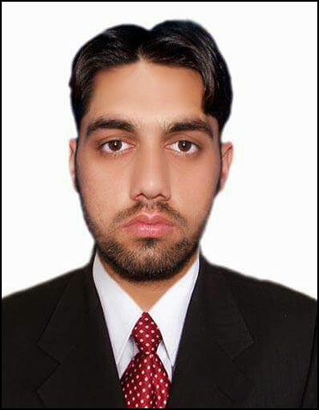
- Maintaining our accounts system
- Arranging financial audits and reviews as required

Education

IQRA NATIONAL UNIVERSITY PESHAWAR
MASTER OF BUSINESS ADMINISTRATION (2011-2015)
- Financial Management policy, Investment Analysis.
- Accounting For Manager, Financial Markets and Institutions.
UNIVERSITY OF PESHAWAR
BECHELOR OF SCIENCE (2008-2010)
- Math’s A, Math’s B, Physics
KHYBER MODEL COLLEGE MANDANI CHARSADDA
F.SC (2006-2008)
- Math’s, Physics, Chemistry
USMANIA PUBLIC HIGH SCHOOL UMERZAI CHARSADDA
SSC (2006)
- Math’s, Physics, Chemistry, Biology

COMPUTER PROFICIENCY
- Word Processing: Microsoft Word
- Excel Processing: Microsoft Excel
- Presentation/ Graphics: Microsoft Power Point
- Have sufficient knowledge to use internet for research & development purposes.

LANGUAGES
- English
- Urdu
- Pashto

References
References are available upon request.

