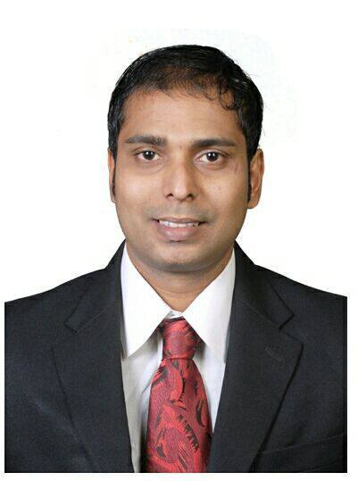
DARYLL
Email : daryll.300940@2freemail.com

career objective:
To seek position in an organization where I can use my skills and experience to contribute positively towards the growth of my employer

PROFESSIONAL EXPERIENCE
Experience: 12 Years (Administration / Customer Service Representative)

Godrej & Boyce Mfg. Co. Ltd.(Through Snp Services)
Mumbai Area, India 03 Dec 2013 –31 Aug 2016

Designation: Office Assistant.

- Prepared schedules, tracking of Bills, Verified Bills and Waiver amount Calculation.

- Follow-up with the collection manager for passing the waiver amounts.

- Coordinated with service providers for billing related issues.

- Conducted cost benefit analysis and handled telecommunication billing of Godrej & Boyce HO, Branches & Showrooms.

- Assigning Data cards of Airtel, Reliance and Tata to Godrej Branches all over India.

- Coordinating with the Admin dept to deliver the card with minimum time frame and keeping Records of the dispatch details.

- Overseeing Tele Marketing data for different branches across the country and doing a follow-up. Proper documentation as per TRAI regulation.

- Verification of Telecom Resources on regular basis. Disconnection of telephone lines as and where required. Request for New requirements.

- Maintaining account of International cards which provides Telecommunication services for International roaming to Godrej Employees. Proper Documentation for them and also Intimate the employee to collect the card. Also prepare analysis of usage for MIS.

- Verifying bills of different service providers (Vodafone, Reliance, Airtel, Tata, Clay Telecom) and prepare requisitions for the same.
(CONTINUED)

Godrej & Boyce Mfg. Co. Ltd.
Mumbai, India Present

- Interacting with the Top Management relating to Data Card queries.

- Preparing MIS (Monthly Information System) for analysis of the Telecom product.

- Maintaining billing resources in an accurate and timely manner for future Audits

WNS Global Services Pvt. Ltd
Mumbai, India 27 Feb2006 – 17 Jul 2013

Designation:Senior Customer Service Associate

- Checked the accounts of British/ Scottish gas Customers and initiated correspondence as part of investigation

- Receiving calls to resolve the queries of British/Scottish Gas Customers.

- Handling complaints and assigned them to the concerned departments.

- Monitoring accounts and gave constructive feedback along with reports for trend analysis. Additionally, worked on SAP application.

- Handling the team in the absence of Team Leader and sent reports to the Manager and the Clients.

- Maintaining high level of accuracy and productivity in attaining high targets given by client. Received appreciation for the highest quality rating given by the customers, including Net Promoter Score for the month of July 2009.

- Additionally, worked with WNS as Customer Service Associate for Air Canada.

- Managing escalations of Air Canada employees and solving queries related to reservation pass privileges, employee travel website and billing queries.

- Handling back office reports of the employees travelling to different destinations and filing them.

RESPONDEZ
Mumbai, India 03Aug 2005 – 08Feb 2006

Designation: Customer Service Associate (Outbound UK Process) for Simply Mobiles.

BPL at Opera House
Mumbai, India 15Jul 2004 – 31Jan2005

Designation: Customer Service Executive.

Prior Experience:
Have one and half year’s experience in the Hospitality Industry. (Worked with Hotel Executive Enclave as Head Steward for one year and worked with Croissants for six months as a Counter Staff).

EDUCATIONAL QUALIFICATION:

B.COM from Mumbai University, IndiaMarch 2002

Completed a course in Food Production from Kohinoor Institute (Dadar)
Securing first class,Mumbai, India April2003

ADDITIONAL QUALIFICATION:

- Completed Lost Dutchman's Gold Mine training from WNS 2010

- Participated in “Understanding Media Reception
Strategies of Youth in Mumbai: An Exploratory Study “Conducted by Unit of Media & Communication at Tata Institute of Social Sciences.

- Obtained Training from B. P. Marine Academy in Elementary First Aid, Personal Safety & Social Responsibilities, Personal Survival Techniques, Fire Prevention & Fire Fighting.

- Completed Certification from Transform Gym as a Personal Trainer

SOFTWARE SKILLS
- Advanced Excel securing Distinction. (Govt. Authorized).
- MS-Office Course securing “A” grade (Govt. Authorized).

EXTRA CURRICULAR ACTIVITIES

- Played Basketball, Football, Carom at Inter Collegiate Level in Senior College.

HOBBIES

- Listening to Music, Dancing, Singing and Working out in the Gym.

PERSONAL DETAILS
Age : 35 years

Religion:Roman Catholic

Nationality : Indian

Languages known : English, Hindi, & Marathi.

Declaration

I hereby declare that the above-furnished information is correct and I am responsible for its accuracy.

Place:
Date:

