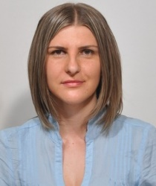
Arna
Graduate Structural Engineer, Master’s Degree

EMail: arna.300510@2freemail.com

PROFILE

I’m an enthusiastic, self-motivated, reliable, responsible and hard working person. I’m a mature team worker and adaptable to all challenging situations. I am able to work well both in a team environment as well as using my own initiative. I am able to work well under pressure and adhere to strict deadlines.

OBJECTIVE

I’m seeking a challenging position as a Structural Engineer where I can use my planning, designing and overseeing skills to help a company grow and achieve its goals and ambitions.

EXPERIENCE

“PBP” Konjic

Civil/Structural Engineer ( October 1st 2015 – present )

EDUCATION & QUALIFICATIONS

Faculty of Civil Engineering, University of Sarajevo, Bosnia and Herzegovina
Department of Construction
Master’s Degree, Major in Structures

Project work during college

- Studying structural Analysis & Dynamics
- Studying different construction Methods
- Calculating requirements to plan and design the specifications of the civil work.
- Studying and implementing different materials such as concrete, steal and wood

TECHNICAL SKILLS
- Auto CAD
- SP 2000
- MS-Office (Excel, Word & PowerPoint)
- Radimpex Tower

LANGUAGES

Bosnian, Croatian, Serbian – Native Speaker
English – Fluent
French – Basic
German - Basic

References available on request

