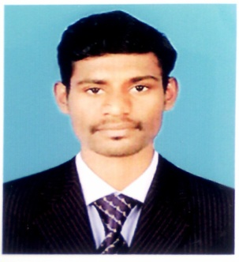
CLEETUS
Cleetus.300636@2freemail.com
DUBAI, UAE

CAREER OBJECTIVE
Seeking a position in Accounts & Finance with a reputed organization where I can perform to the best of my abilities and my skills for the benefit of the organization.
CAREER HISTORY:
- MBA in Finance graduated with 1+ year professional experience in field of Accounts/Finance in India.
- An adaptable, lateral thinker and quick learner who has extensive knowledge of accounts payable, receivable procedures and general accounting processes.
- Account Assistant, in ACHARYA VIRTUAL SOLUTIONS PVT.LTD, INDIA FEBRUARY 2015 – JUNE 2016.

ROLES AND RESPONSIBILITIES:
- Dealing with accounts payable and receivable.
- Report to Chief Accountant by preparing monthly financial performance statements.
- Handling telephone inquiries relating to accounts payable issues.
- Invoice processing for payment.
- Prepare the Sales Invoice
- Finalize Trial Balance with supporting schedules.
- Prepare Payroll and Management Information Reports.
- Reconciliation of bank statement.
- Manage the day to day financial transactions of the company.
- Monitoring and recording company expenses.
- Assisting in the finalization of accounts.
- Compiling management reports and assisting with audits.
- Manage the Invoice generation Operation & Credit Control.
- Entering Supplier Invoices into the accounting system.

KEY SKILLS AND COMPETENCIES
- Strong Microsoft Office skills; proficient in Excel, and Tally ERP.
- Computing, classifying, and recording numerical data to keep financial records.
- Ability to multitask and prioritize daily requirements.
- Excellent analytical, reconciliation and overall troubleshooting skills.
ACADEMIC QUALIFICATION
- MBA (HR & FINANCE) –DMI College of Engineering, Chennai in 2015
- BBM (MANAGEMENT) – Scott Christian College, Nagercoil in 2013

CERTIFIED COURSE
- Tally ERP
- Ms-Office-Excel
PERSONAL DETAILS
DOB : 10/07/1991
Nationality : Indian
Marital status : Single
Languages : English & Tamil
Visa Status : visiting visa
DECLARATION
I hereby declare that the information furnished above is true to the best of my knowledge.
Signature,

