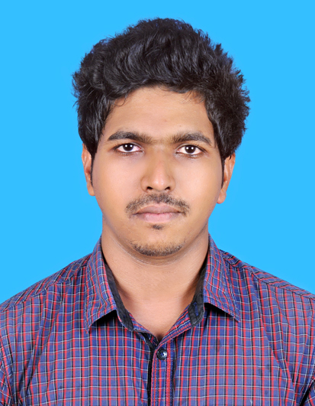
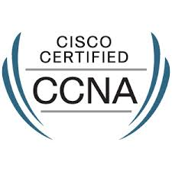

BRIJITH
BRIJITH.300653@2freemail.com

OBJECTIVE

To work for an organization which provides me the opportunity to improve my skills and knowledge to growth along with the organization objective.

KEY SKILLS

- Configuring Routing Protocols – EIGRP, BGP, OSPF, VPN, Policy based routing, NAT and DHCP.
- Configuring VLANs, VTPs on Cisco Switches, Inter VLAN Routing, Advanced Switching Protocols and Advanced Spanning-Tree Features. PVST, RSTP, MSTP.
- Positive attitude and ability to work with various departments and foster teamwork.
- Analytical Skills, Ability to Work under Pressure, Decision Making & Problem Solving Skills.

PROFESSIONAL EXPERIENCE

Network Support Engineer, Netwing Technologies, Kannur, Kerala

March 2015 – May 2016

Key Responsibilities

- Configuring, Supporting and Troubleshooting Routing and
- Switching technologies based on Cisco Switches and Routers.
- Configuring Trunking and Pruning on Switched Network.
- Configuring and Troubleshooting VLANS in Switched Networks.
- Patching and Monitoring.
- Participate in Conference meetings to discuss periodic updates of the project.
- Contact our clients on various stages of a project.

Service and Installation Engineer, Magnum Network Support Pvt. Ltd, Hsr Layout, Bangalore

March 2014 – March 2015

Key Responsibilities

- Implementation of security devices like Camera, Access control, Fire alarms, Temperature sensor.
- Termination of cat6-A cable.

- Fluke testing of cat6-A cable.
- Implementation of server room
- Dressing, Patching, Rectification of cat6-A cable

Technician, CCTV Technologies Pvt. Ltd, Cochin, Kerala

September 2012 – September 2013

Key Responsibilities

- Working as Technician.
- Configuring, Supporting and Troubleshooting IP based CCTV products.
- Troubleshooting hardware related queries to customer over phone.
- Assisting in sales.

Computer hardware engineer, Tentacles Technologies, Kannur, Kerala

February 2011 – April 2012

Key Responsibilities

- Computer assembling and maintenance.
- Installing software and application to user standards.
- Expertise hands in troubleshooting of computer hardware related problems
- Such like UPS, SMPS, Printer and Drivers.
- Assisting in sales.

EDUCATION

- DIPLOMA In Electronics ( 2009) State Board Of Technical Education Kerala

- Cisco Certified Network Associate R&S (CSCO12839354)

- Cisco Certified Network Professional R&S (CSCO12839354)

PERSONAL DETAILS

Date of Birth : 10 January 1989
Sex : Male
Nationality : India

Driving License : India
Languages Known : English, Hindi and Malayalam

Declaration
I hereby declare that the above information is true to the best of my knowledge and belief.

