CURRICULUM VITATE
Shivamalatesha.300830@2freemail.com 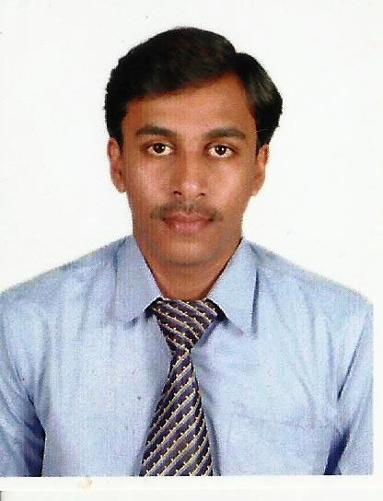
From,
Shivamalatesha

Career Objective:
Looking forward to utilize my 8 years 7 months of experience as Blood bank Technician & Lab Technician. With reference to the above, I wish to bring the following few lines for your kind notice and consideration. Having worked with reputed organization & highly Regarded super specialty cardiac Hospital with specialty Neuroscience. Narayana Hrudalayalaya, Bangalore. I have worked in WOCKHARDT HOSPITALS BANGLORE.I have worked in Mrs.SAVANTRAMMA MEMORIAL Hospital.Hangal & I haveworked in Dhanvantri Ayurveda collge ,Hospital and Research Centre. Perusing my BAMS(A.M) By IBAM Academy Kolkata.
Career Highlights:
- Experience in the Department of Haematology,Blood bank and Phlebatomy.
- Experience in Handling individual Departments.
- Excellent Interpersonal & communication skills.
- Energetic and Adaptable.
Skill summary :
- Effective care of Medical test reports.
- Professional skill in Donor and patient care & medical management .
- Expertise in Handling all emergencies.
- Expertise in Handling individual Department.
- Expert in assessing complications.

Professional Profile:
Diploma in Laboratory Technology 1st | 2004-05
Diploma in Laboratory Technology 2nd | 2005-06
Diploma in Laboratory Technology 3rd | 2007-08
B.A.M.S(A.M) By IBAM Academy Kolkata | Pursuing

Employment and Experience Details:
1.Name of the Hospital : Narayana Hrudayalaya Institute of Medical Science Bangalore .
2.Name of the Hospital : Wockhardt Hospital at Bannerghatta Road Bangalore.
3.Name of the Hospital : Smt. Savantravva yellappa Malode Hospital. Hanagal
4.Name of the Hospital : Dhanvantri Ayurveda college,Hospital and Research Centre
TECHNICAL KNOWLEDGE:
BLOOD BANK & TRANSFUSION MEDICIN:
- T-ACE(AUOTOMATED BLOOD COMPONENTS SEPARATION)
- VITRO BIOVUE CARDS (CROSSMATCH BEAD TECH)
- DIA MED BIOVUE CARDS
- RED SERIOLOGY
- SERIOLOGICAL SCREENING FOR TRANSFUSION TRANSMITED DISEASES
- BLOOD COMPONENT SEPARATION
HEMATOLOGY:
- SYSMEX KX- 21, XP SERIES (XP-100,XP-300)
- BENESPHERA BRAND 3-PART DIFFERENTIAL ANALYZER H31
- i-COUNT 3+
- ASYXM [HIV,HBsg,HCV.]

Personal Profile:
Name : Shivamalatesha
Sex : Male
Date of birth : 24.06.1985
Nationality : Indian
Course studied : Diploma in Medical Laboratory Technology(DMLT)
Name of the college : Goutham college of Paramedical Bangalore.
Computer Proficiency : MS-Office,Internet

Lingestic knowledge:
To speak : Kannada, Hindi, English, Malayalam,Tamil,Telgu
To Read : Kannada, Hindi, English

Declaration:
I here by declare that the above mentioned information correct up to my knowledge and I bear that responsibility for the correctness of above mentioned particulars

