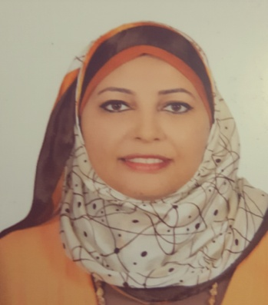
ASMAA
CHEMICAL ENIGNNER

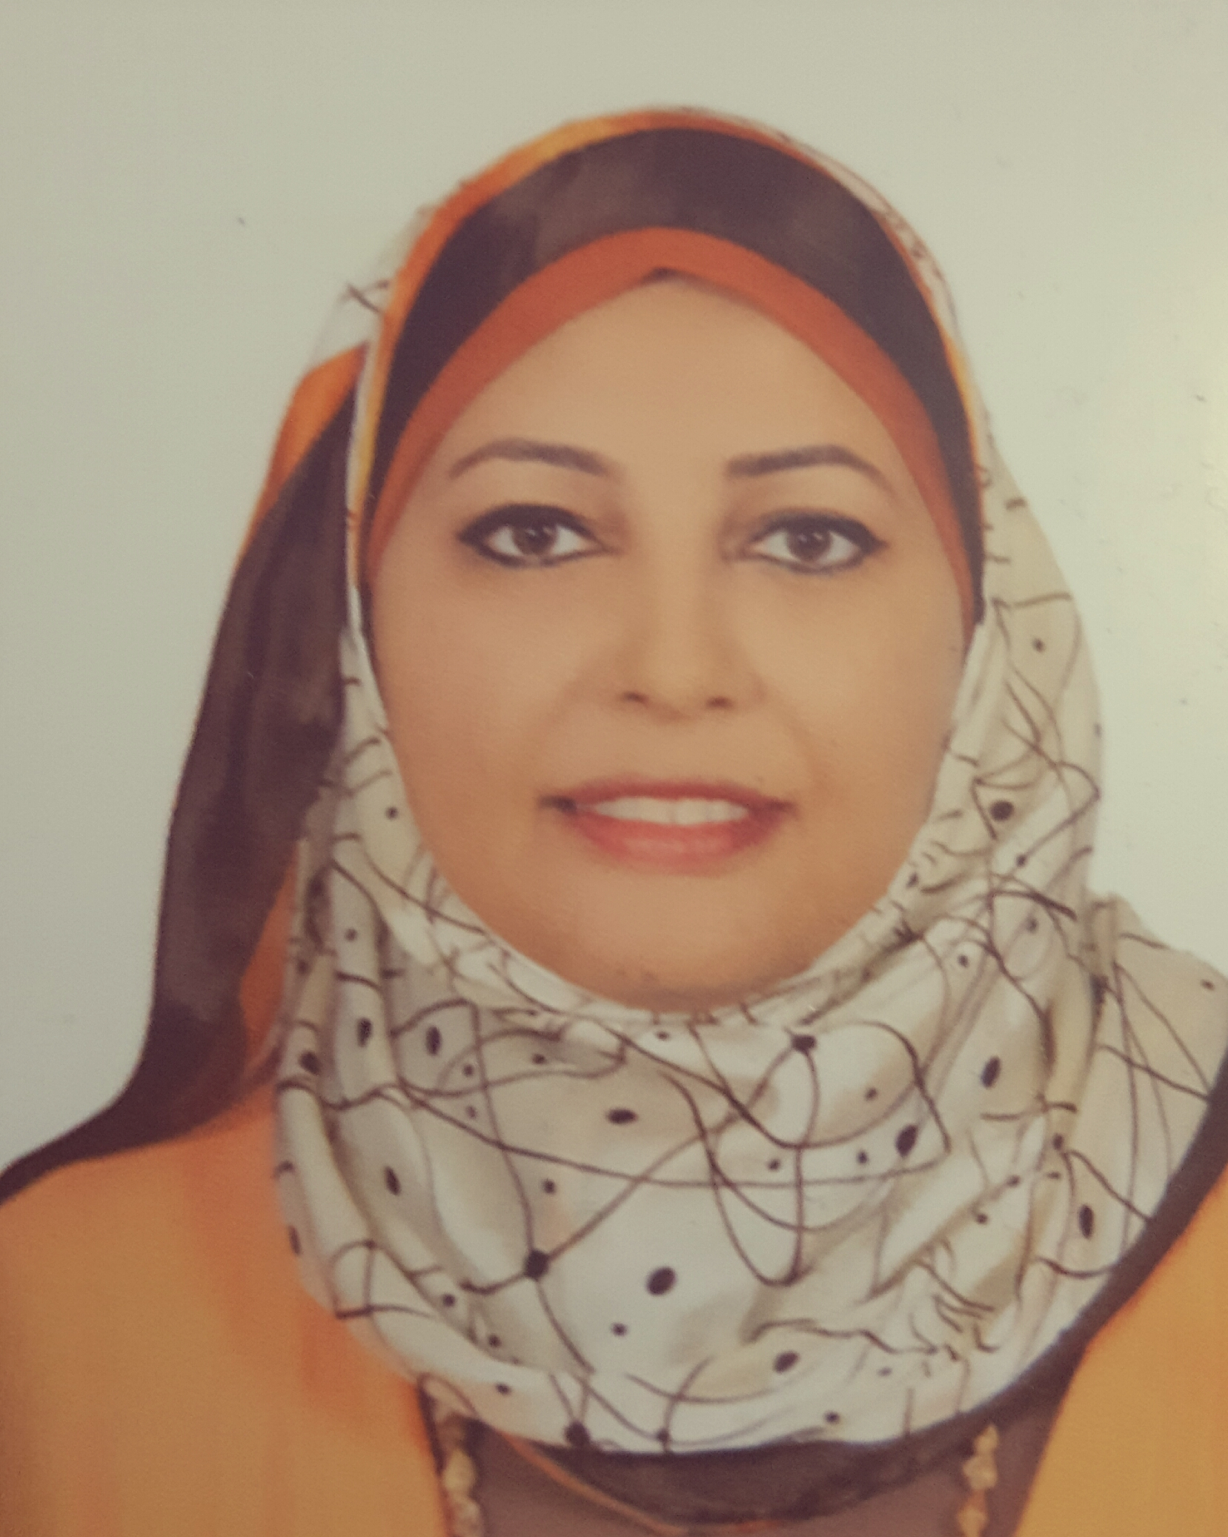
ASMAA.301539@2freemail.com
PROFILE

A results driven individual that combines a professional and confident approach with
Excellent communication skills. Always ready for progression and new challenges.
Wish to expand my experience, welcoming any new opportunities to further progress
My career.

EPERIENCE

Poly star industries – Dubai Dec 2014 – present
Quality control engineer

- Check online for plastic product.
- Taking samples as reference and making inspection like measure weight, wall thickness, opening force, leakage test, and ability for opening and closing caps.
- Making daily reports.
- Check incoming raw materials like cartons poly bags, plastic raw material.
- Give approval for any new product.
- Check and solve customer complaints.
- Arrange with customer for any product as per specifications.
- Make internal audit for ISO 9001, HACCP for food safety.

MRI, Egypt Nov 2013 – Nov 2014
Project engineer

- Study any new project and make study plan.
- Follow power and water consumption and how to reduce it to save cost.
- Check housekeeping for the production area, analysis and solve any problem like pump leaking or compressor problem.
- Connect with different suppliers regarding to any new pump or compressor as per our specifications.
Alexandria Petroleum company, Egypt Nov 2011 – Nov 2012
Chemical engineer

Training at distillation field, water treatment, oil field. -
Personal information
 |  | DOB | 17/04/1990
 |  | Nationality | Egyptian
 |  | Languages | Native Arabic, Fluent English,
 |  | Driver’s License | Under process

Education

Collage of engineering –Alexandria University, Egypt
-Bachelor of chemical engineering class 2013
ProfessionaL COURSES

1-Introduction to project management system ''24 hrs '' march 2016.
2-Introduction to people management ''20 hrs '' march 2016.
3- ISO 9001 awareness, implementation and audit ''15 hrs '' 2015.
4 -HACCP awareness, implementation and audit '' 15 hrs '' 2015.
5- Heat transfer equipment design ''14 hrs '' 2011.
6-static refining course ''14 hrs '' 2012.

