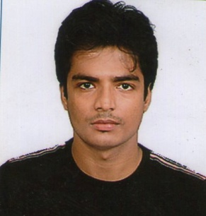
Hani

Hani.301671@2freemail.com
Education
- B.Com Graduated from University of Calcutta year 2011
- High school Diploma from Collins institution year 2008
- Diploma in financial system year 2013
Skills
- Accounting
- Reports & documentation
- Inventory check-up
- Call centre operations
- Front Desk Operations
- Experience with computer programs (Word, Excel, Windows XP, Windows ME, Word Perfect, Tally, Adobe Photoshop, PowerPoint, Access, many custom made company programs)
Professional Experience
- Worked as a Back office Supervisor for 3 and half years in J.D.Service PVT LTD
- Worked as a Relationship Manager in a wealth management firm for 1 year.
Activities & interests
- Front office assistant
- Stock market research
- Business & channel development
- Forecasting & Market analytics

Personal Details
Nationality : Indian
D.O.B : 06/09/1990
Sex : Male
Marital Status : Unmarried
Languages Known : English, Hindi

Carrier Objectives
To work in pragmatic way in an organization where I can show my talent and enhance my skills to meet company goals and objective with full integrity and zest.
And I believe in positivity because its simplify the gesture of life.

