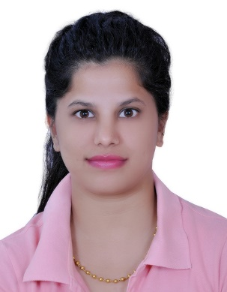 Priyanka
Priyanka.301825@2freemail.com
A result -oriented and passionate professional with 3 years’ experience in assessing patients and interpreting core evaluations to determine the nature of illness or dysfunctions.
I am a highly motivated and qualified occupational therapist with a passion for promoting health and well being at work and in everyday life.

Experienced in the development and management of care plans and the performance of ADL, workplace assessments, seeking a role in an esteemed practice where I can utilize & leverage my skills and contribute as part of a team.

RELEVANT SKILLS

• Neurodevelopment Techniques (Sensory Integration)
• MMT and ADL

These includes treating the following difficulties:

• Gross Motor & Fine Motor skills
- Visual perception skills
- Self care skills
- Handwriting difficulties
- Concentration difficulties

Conditions worked upon in treating children:

- Autism & Sensory processing disorder
- Cerebral Palsy
- Mentally challenged
- Learning disabilities

PROFESSIONAL PROFILE:
Worked as an Occupational Therapist in Nidhi Rehabilitation Centre Indore (INDIA) from 1.07.2012 to 1.08.2015
1st January’08 –January’09: Shalimar Physio, Indore as Occupational Therapist (Part Time)
1st January’08 –30th September’09: ERGO Care, Health Rehabilitation Centre Indore as Occupational Therapist (Part Time)

ACADEMIC QUALIFICATION:
Master of Business Administration with specialization in Hospital Administration & Health Care Management.
From: Jayoti Vidyapeeth women’s university Jaipur, Rajasthan,India
Graduated-2012

Bachleor of Occupational Therapy
From: Indore Institute of Medical Sciences, Indore, Madhya Pradesh, India
Graduated – 2010

Management trainee:

- 90 days training certificate S.K.SONI HOSPITAL JAIPUR
- 30 days training certificate JEHANGIR HOSPITAL PUNE
- 15 days training certificate S.K.SONI HOSPITAL JAIPUR

Topic covered:

IMPROVING PATIENT CARE &REDUCING TURNOVER TIME ICU | MAY-JULY 2012
QUALITY INDICATOR FOR PHYSIOTHERAPY | AUG-SEP 2011
NABH STANDARD | MARCH 2012

EXTRA – CURRICULAR

- Appeared in national level science talent search examination -2002
- Won first prize in group dance -2000
- Appeared in united schools’ organization of India -1997 for junior general knowledge test certificate
- Attended workshop on role of electrical modalities in rehabilitation in indore-2007
- Certificate for student member of ALL INDIA OCCUPATIONAL THERAPISTS ‘ASSOCIATION-2008 TO 2009
- Awarded participation certificate in the 44 annual national conference organized by AIOTA at Indore
- Awarded participation certificate in the 46 annual national conference organized by AIOTA at Jaipur
- Awarded participation certificate in the 47 annual national conference organized by AIOTA at Ahmed
- Awarded certificate for first attempt in passed examination in occupational therapist

KEY SKILLS AND ATTRIBUTES:

- Committed team player with flexible approach to work and to take initiative whenever required.
- An extrovert who likes interacting with people and adaptable to changes.
- Clear understanding of facts before taking any decision.

Personal information:

- Nationlity : Indian
- Date of birth : 09.06.1986
- Marital status : Married
- Visa status : Husband visa
- Language : English,hindi

