CURRICULUM VITAE of MOUSSA
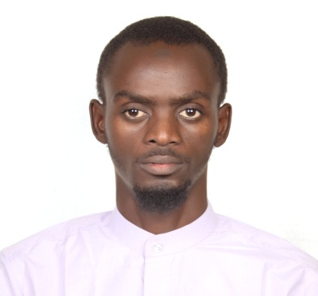
Email: moussa.301842@2freemail.com
Personal Information
Nationality: Chadian
Gender: Male
Languages: English, French, Arabic and Basic Hindi
Career objective
I would like to be a part of an organization where I could use and enhance my knowledge and talent for the development of both the organization and myself.
Summary:
Professional with two years of professional experience and progressive technical experience as a Freelancer in networking(Cisco and Microsoft) and web development at abbandjita.com in which I am the founder, team leader and project manager of Abbandjita Technologies where we create websites for companies and design network and solve internet issues and some different technical issues in IT fields. And I am a CCNA and CCNA Security instructor and founder of tchadnet.com.
ACADEMIC QUALIFICATION-:
S. No Class/ Degree Stream College/Board /University Year
1. Class I to VI: ECOLE PRIVEE DE LA PROPERITE (CEPET) 2003
2. Class VII to X: LYCEE CLLEGE LE “SULTAN” (BEPECT) 2007
3.Class XI to XIII: LYCEE DE LA FIDELITE (Baccalaureate serie D) 2010
4. Graduation BCA at OSMANIA UNIVERSITY 2011-2014
5. MSC(IS) (2014-2016) at OSMANIA UNIVERSITY.
TECHNICAL KNOWLEDGE
NETWORKING TECHNOLOGIES
• Cisco Certified Network Professional(CCNP) (Routing , Switching & Trouble shooting)
• CCNA Security
• Basics of CCNP – Security(Secure,Firewall and VPN)
• Microsoft Systems Administrator (MCITP-2008)
•Hardware Skills: Computer Assembling & Installation , Operating Systems: Win XP, Windows 7, Red hat Linux-6 and Software installation (OS, Software’s), Desktop support, Antivirus, CCTV Security
WEB TECHNOLOGIES:
HTML,CSS,HTML5,CSS3,PHP/MYSQL, DREAMWEAVER, CMS(WORDPRESS, JOOMLA & MAGENTO JAVASCRIPT HOSTING AND DOMAIN Graphic Design : Photoshop/Illustrator.
Recents website by me: aasi.org.in, prfsca.com kabantilimited.com, sudachatit.com abbandjita.com, sudatchad.com , newtajfurniture.com , space-academy.in, tqtpaint.com, technotcahd.com tchadnet.com(updating soon) givafrica.org(in progress) clandotaxi.com(in progress) and ppp-tchad.com(in progress)
TECHNICAL CERTIFICATIONS
• Cisco Certified Network Associate (CCNA) (routing and switching track) Cisco-ID: CSCO12628671
• Cisco Certified Implementing IP Routing (CCNP-Route) Cisco-ID: CSCO12628671
•Cisco Certified Implementing Cisco IOS Network Security (CCNA Security) Cisco-ID: CSCO12628671
ADDITIONAL INFORMATION
- Worked as IT PROJECT MANAGER with AASI(Association of African Students in India)
- Completed Internship with BEAC(Banque Des Etats de l’Afrique Centrale)
I hereby declare that all particulars furnished above are true, complete and correct to the best of my knowledge and belief.
I am available to come in for an interview at any time, and would appreciate the opportunity to meet with you and your staff. I hope that I am granted an opportunity to talk and perhaps meet with you in the very near future.
Hope to hear from you soon.
Yours sincerely

