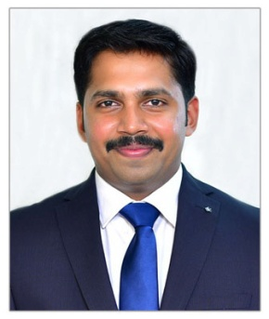
ANI
Sales & Marketing ~ Finance
Acknowledged for strengthening companies to lead in highly competitive markets and delivering innovative marketing concepts & strategies
ANI.31572@2freemail.com

Profile Summary

- MBA (Marketing &Finance) with over 5 years of experience in Sales and Marketing, Operations Management and Risk Management
- Independent self-starter with strong work ethic and a high level of initiative and motivation
- Experience in conceptualizing & executing plans to drive business growth & achieve desired target as well as monitor competitor activities to retain market share
- Possess skills in cementing healthy relationship with clients for generating and augmenting business
- Capabilities in developing high net worth business by coordinating requirements, developing & negotiating contracts
- A keen communicator with honed interpersonal, problem solving and analytical skills

Career Timeline | Area of Excellence
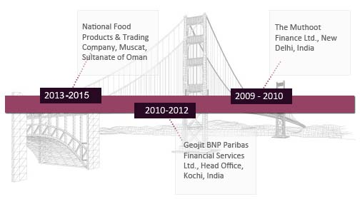  Education  - MBA (Marketing & Finance) from SNR Son’s College, Coimbatore, Bharathiyar University in 2009 with 77%  - Advanced Diploma in Sales Promotion Management from SNR Son’s College, Coimbatore, Bharathiyar University in 2009 with 70%  - Bachelors in Economics from MSM College, Kayamkulam, University of Kerala in 2006 | 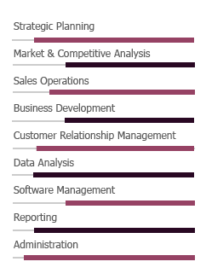
Work Experience

Jun’13– Dec’15 with National Food Products & Trading Company, Muscat, Sultanate of Oman as Sales Supervisor
Growth Path:
Jan’15 – Dec’15 Sales Supervisor
Jun’13 – Dec’14 Sales Executive
Key Result Areas:
As Sales Supervisor
- Supervising overall activities which include sales, distribution, customer service and administration while focusing on achieving the sales & collection target set by the company; providing Sales & Market Intelligence Report to senior management
- Developing strong market knowledge of existing and potential clients and ensuring business growth opportunities aligning to company’s strategic plans & policies on financial and sales related matters
- Supporting marketing related events, seminars, mailers and call campaigns to increase brand awareness and presence in the local market
- Growing and maintaining existing customer and partner relationships in territory by utilizing question based selling methods to ascertain customers’ needs to craft relevant solutions / products
- Coordinating with the Accounts Department in maintaining the payment status of the customers
- Preparing contracts and responding to customer needs; developing new business deals by coordinating requirements, and negotiating contracts

As Sales Executive
- Strengthened relationship with strategic account by leveraging key account management skills and developing new and untapped potential customers
- Followed-up with all the major clients / customers regularly; dealt with after-sales queries, investigated customer complaints and ensured that they are resolved till customers' satisfaction
- Reported to the Sales Manager regarding movement of goods / brands; ensured timely payments of outstanding balances according to the payment terms

Highlights:
As Branch Supervisor
- Identified niche markets in these Ash Sharqiyah region, Oman regions and new / future services that provided the company with a competitive advantage and improved profitability
- Achieved/exceeded monthly sales targets and gross profit quota by identifying, prospecting and qualifying new customers and selling through strategic partners in a geographic territory of Ash Sharqiyah region
- Submitted accurate & timely forecasts that were aligned with assigned sales quotas; surpassed sales targets.
As Sales Executive
- Worked with the group marketing team to develop marketing campaigns to support sales strategy; generated new business and raised awareness of other company products
- Developed the current prospect database of clients to generate effective leads & exceeded sales targets.

Nov’10 – Sep’12 with Geojit BNP Paribas Financial Services Ltd., Head Office, Kochi, India as Executive - Risk Management Operations

Key Result Areas:
- Managed the branch operations in order to minimize the risk and encourage business of the firm; organized and managed staff resources according to changing environment; monitored all risk-related activities
- Offered guidance to the branches in resolving functional queries and identifying areas of improvement; suggested best practices that offered cost / productivity savings and ensured excellence
- Examined and approved credit / margin proposals from branches or through regional managers to clients in line with company’s credit policy and regulatory guidelines
- Directed loss prevention / loss retention programs; suggested recommendations to higher authority
- Generated internal risk monitoring reports on a daily basis and reported it to higher authority

Highlights:
- Embedded behaviours and competencies such as automated clearance of due debits by selling the pledged shares that created a risk management mind-set in the organization
- Facilitated training of control-related topics
- Liaised with Internal Audit Team, Business Unit Heads and Corporate Compliance on behalf of the division; assisted in resolving identified issues and monitoring their resolution

Aug’09 – Aug’10 with The Muthoot Finance Ltd., New Delhi, India as
Accounts Executive

Key Result Areas:
- Provided assistance to the Branch Manager in the day-to-day activities of the branch, finance planning and other operations activities; acted as the custodian for the safe locker and managed the safe locker operations
- Coordinated with bank for daily transactions & fund management; followed-up with clients on pending invoices & receivables
- Managed cash counter operations and maintenance of appropriate cash / accounts registers and ledgers electronically and manually according to the organization’s accounting norms
- Prepared daily / monthly account statements and related reconciliations; liaised with the auditors and helped them in conducting periodical or special audits

Highlights:
- Accelerated the monthly reconciliation process from 3 days to 1day task through measures such as weekly reconciliation of internal ledgers except bank
- Recorded all accounting entries in ERP Software

Training & Certifications

- Professional Excellence Training conducted by Anglo-Intelligentsia, 01 Jun 2016 – 29 Jul 2016

IT Skills

- Familiar with Windows, MS Office, MS Outlook, Tally, CRM & MRM Software and Internet Applications

Personal Details

Date of Birth: 3rd January 1986
Marital Status: Married
Nationality: Indian
Languages Known: English, Hindi, Malayalam, Tamil and Arabic
Visa Status: Visit Visa (Valid till 17/11/2016)
No. of Dependents: 1

