Kadhar
Kadhar.302773@2freemail.com

Result-oriented Professional, targeting challenging assignments in Trade Finance / Finance & Accounts with a growth-oriented organization of repute; preferably in GCC Countries

PROFILE SNAPSHOT

- General Accountant with over 13 years of experience in Trade Finance, Finance & Accounts, Treasury Management, Auditing and Team Management
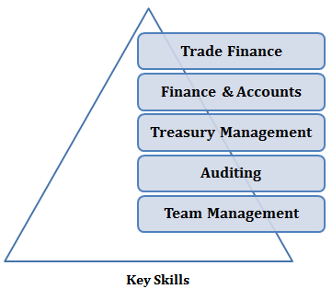
- Expertise in designing systems & procedures and contributing towards improved financial performance, heightened productivity and enhanced internal controls
- Excellence in managing branch operations and implementing strategies towards enhancing market penetration, business volumes and growth
- Proficient in managing issuance of all types of Letters of Credit, Guarantees, LC Confirmations, Transfer of LCs, guarantees, court cases, collection documents (Trust Receipt/Avalization), and so on; skills in managing all software in connection with cheque deposits, signature verification, cash deposits, and so on
- Accomplished in managing financial accounting, receivables & payables management, bank reconciliation statements and finalization of accounts
- Possess exceptional relationship building, analytical and communication skills

ORGANISATIONAL EXPERIENCE
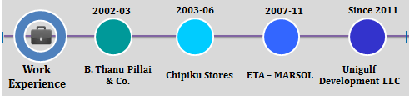

Since Oct’11 Unigulf Development LLC (HVAC – Manufacturing & Trading), Dubai as General Accountant

Apr’07 – Sep’11 ETA – MARSOL (Shipping Division), Marine Logistics Solutions, Dubai as Finance Executive

Sep’03 – Nov’06 Chipiku Stores (Chain Super Market), Malawi, Central Africa as Asst. Internal Auditor

May’02 – Aug’03 B. Thanu Pillai & Co. (Audit Firm), India as Trainee

Key Result Areas:
- Establishing operating model for the Trade Finance business and spearheading operations of the Trade Finance Department including counter-trade, pre/post-shipment financing and structuring of complex deals from inception to conclusion
- Utilising Trade Finance products like Letter of Credit, Trust Receipts, Avalization, and so on
- Managing Import & Export L/C’s and monitoring L/C Discounting, Invoice discounting (Factoring) & Cheques discounting
- Supervising treasury activity like Fund transfer, Forex deal and so on with banks
- Performing activities such as credit planning to arrive at credit risk, cash flow management and monitoring A/R & A/P on regular basis
- Maintaining stock, minimum quantity, maximum quantity & reorder level, stock checking and verification in branches
- Planning and executing monthly / quarterly / annual closure schedules; provided monthly financial statements; administered the monthly closing process
- Creating and explaining weekly profit & loss projections; establishing product line profit & loss statements to identify opportunities and risks
- Reviewing all treasury transactions and documents such as Overdraft Facility, Export & Import LCs, Trust Receipt, Avalisation, Advice Bill, Foreign Currency Purchase, Fund Transfer, Discounting Invoices & Cheques and so on
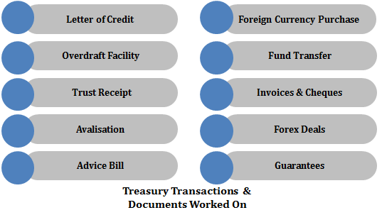
- Ensuring matching of invoices, debit/credit notes, delivery notes, purchase orders, goods receipt notes, vouchers and other related documents before creating any accounting entries
- Preparing and reconciling monthly income schedules to identify income included in monthly management accounts
- Responsible for completing monthly financial closing procedures including month-end accrual entries for the company.
- Analysing capital expenditure additions in the month
- Coordinating for all outward remittances and tracking interest payments to banks
- Processing refunds of customers through banks or the payment gateway
- Compiling MIS Report with Ratio Analysis (Profitability Ratio, Working Capital Ratio & Activity Ratio and so on)

Highlights:
- Contributed to the development of the Trade Finance area like convincing and guiding several suppliers from different types of payment into Trade finance related products like (TR, L/C, Avalization, Self Discounting L/C) and similarly negotiate the bank to enhance the facility with low interest rate.
- Negotiated Letter of Credit (L/C), Bank Notes, Documentary Credits and Credit Lines in excess of US$ 7 Million
- Key member of the team that migrated the Export L/C discounting from one Bank to Another Bank with Low interest Margin and other charges
- Managed to convince the Management for online banking for all the bank accounts (14 accounts) successfully and operating most of the transactions such as internal transfers, third party transfers, utility bill payment and few trade finance related activities through on-line banking which saved considerable amount of time and cost

ACADEMIC DETAILS

- 2002 - M.B.A. (Finance) from University of Madras, India

Other Course:
- Pursuing CDCS (Certified Documentary Credit Specialist) from Phoenix Educational Institute, Karama, Dubai.

IT SKILLS

- Oracle-based Accounting Software
- SAP – FI Module
- Accounting Package Tally 9
- Software Package –MS Office (Word, Excel & Access)
- Windows OS
- Internet Applications

