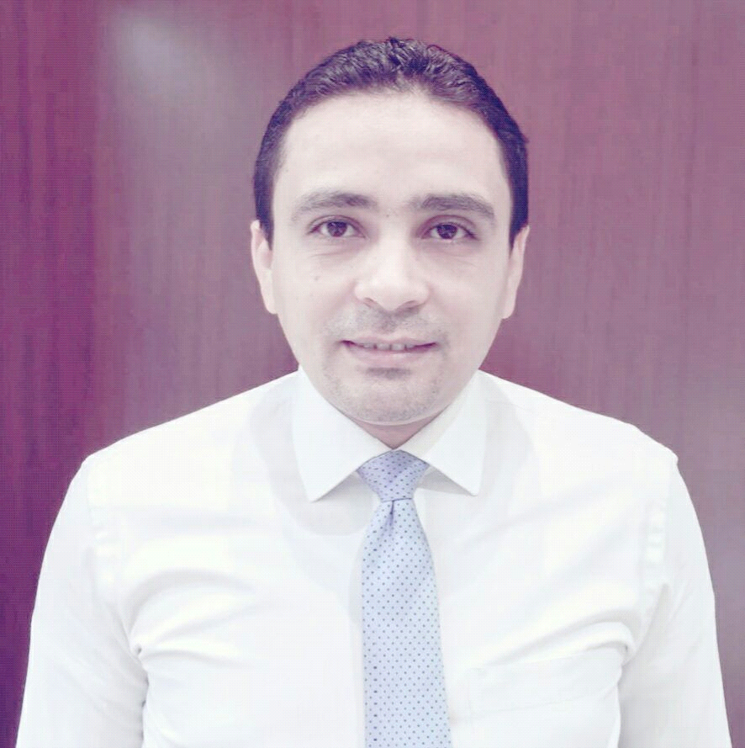
moataz.303332@2freemaail.com

CAREER profile:

Qualified luxury sales management with professional experience& background in both of U.A.E & K.S.A &A.R.E with various reputed organizations. I am a result driven and experienced executive with a vast exposure in Sales, marketing and Business Development,
PERSONAL INFORMATION :
NAME | Moataz
Nationality | Egyptian
Visa status | Employment visa
Contact number
Contact email
driving licene | UAE .

WORK EXPERIENCE

Work at ( pure gold jewellry ) as ( area sales executive .) at dubai ( 2016 :...........)
Duties and Responsibilities
0Reach the yearly budget by continuously monitoring accounts performances, tailoring strategies & action plans to maximize retailers sales (‘sell-out’ strategy more than ‘sell-in’);
o Monitor stock level and collaborate with logistics department in Hamburg to ensure
o Optimization of monthly stock allocation;
o Manage the backorders of the clients through: reorder, cancellations, follow-up on deliveries and order of new collections;
o Establish a strong partnership relation with clients and develop communication with duty free operators;
o Occasional travels to each market to control brand level stock & assortments, to work on monthly orders as well as visibility;
o Organize and perform training sessions in order to enhance knowledge of sales teams on the brand and on the products.
Help in the elaboration of the annual strategic business plan such as budget presentation;
o Prepare Sales Forecast per clients for TFWA & SIHH;
o Analyse & control customers’ margin to ensure profitability of the account;
o Identify prospective clients/markets and assess business opportunities.
o Monitor & Analyse competitor activities in the market.
0 INVOICES COLLECTION
o Monitor invoices for A&P, S&D, airlines listing fees
MARKETING COORDINATION.
Main communication channel with HQ and with the local supplier for the visual production (specific launches, marketing campaign, forecast consolidation of POSM/training material)
o Coordinate the promotion, special booster and incentive program on operations leve
ACCOUNT MANAGEMENT.
Review every quarter the assortment for each account (identify slow movers and take the necessary corrective actions to reduce stocks);
o Work on action plans to increase sell out;
o Ensure a constant no out of stock policy on active references;
o Follow-up on payments and credit limit compliance;
o Implement and follow up of Merchandising and POS Material;
o Communicate & follow up on after-sales requests with the logistics department

*worked at ( damas jewelery ) as assistant boutique manager at dubai from ( 2013 : .......)
Duties and Responsibilities
1- Provide good service standards in accordance with company’s philosophy
2- Consistently strives to offer assistance to achieve high quality service and ensure 3consistent service standards across team members
4- Lead, motivate and manage store team to achieve targets
5- Building team spirit and motivating the team by bringing out the best qualities of each team member
6- Achieve sales targets and understand sales expectations
7- Understand and interpret store P&L and exercise good operating expense control
8- Analyse sales trend and ensure store revenue and per cap growth
9- Increase team member’s productivity with the implementation of labour matrix
10- Understand store assortment mix
11- Manage good store inventory control & loss prevention measures
Partner with Visual merchandising team to enhance store visual display to enhance sales revenue
12- Develop and implement policies, procedures and processes for the respective function/department and ensure reviewing and keeping the existing ones updated as part of the ‘continuous process improvement’.
13- Manage implementation of relevant electronic systems to bring efficiency and effectiveness existing processes. Set objectives/ KPIs/ milestones for the respective department/ function and conduct appraisals for direct reports on Electronic Performance Management System.
14- Ensure that team members are provided learning and career development opportunities by identifying successors within the team, preparing them for the next accountable roles and recommending them for external trainings whenever required in consultation with HR Department.
15- Ensure that productivity and service delivery of the department is improved on continuous basis by keeping team members motivated and retained.
Any other duties as may reasonably be requested by the management team

*worked as ( operation in charge ) AT at albaddad international at dubai from ( 2010: ......... )
Duties and Responsibilities:
1- Communicating, maintaining and developing client relationships;Making outbound calls answering customer queries relating to theBusiness
2- Arranging callbacks to ensure that the new business pipeline is managed well
3- Scheduling and manage the key meetings on behalf of management
4- Follow up on outstanding payments ensuring that the business cash flow is wellManaged
5- Placing directcalls and e-mails to clients;Creating and maintaining various reports for management to track new / existingbusiness and payments
6- Preparing and editing correspondence, reports, documents;Follow up with suppliers on orders placed and delivery related queries
7- Ensure daily records are well maintained;Managing vendor relations and registration process.
8- Preparing initial proposals to be sent to clients.
9- Preparing invoices, receipts and manage all the after sales processes of the company.
10-Keeping the Facebook page and Instagram updated and Coordinating orders and inquiries from customers (website and Facebook) .
11-Attending to events for network purposes and to promote our products.

*worked as ( shope in charge ) at ad.group. in arabian oud at dubai .( 2010 ....
Duties and Responsibilities:
Sales Achievement
- Achieve the sales target allocated .
- Participate with the sales executive team in generating sales through high selling techniques.
Customer Service
- Build and maintain customer relationships in order to build strong loyalty.
- Ensure consistency in customer service delivered and handle all complaints.
merchandising guidelines.
- Conduct daily walk through's to check presentation standards.
Man Management
- Prepare schedule to ensure full coverage of the shop floor and maintain grooming standards of the staff.
- Second the Shop Manager in defining areas of responsibility for each sales team member.
- Manage, engage and guide the team reporting to him/her.

*worKED as (SALES executive ) at ALEMTIAS company in dubai ( 2007 .
Duties and Responsibilities:
0 Achieving the target of sales revenue.
0 Monitoring the sales effectively in the area with the objective of maximizing sales performance and developing new business in the region
0 Very good product knowledge and providing training to junior staffs
0 Prepare database in all existing customers and maintaining it by effective sales, coordinating with our distributors and dealers
0 Look after the entire retail channels wholesale and corporate business in the area specified to meet the target Achieving
0 Improve the visibility of the product and increase sales by creating promotions and incentives
0 Issuing pro forma invoice to confirm the orders of the customers, issuing purchase order and coordinates with other department for following up the delivery & payment Monitoring the sales effectively in the area with the objective of maximizing sales performance and developing new business in the region

*WORKED AS (customer service ) AT NATIONAL BANK .AT.A.R.E from ( 2004 : ...... )
- Identifying and establishing contact with potential customers proactively.
- Responding to the inquiries from new and existing customers.
- Meeting annual s goals .
- Maintaining the bank contacts database management with up-to-date contact, accurate and activity details.
- delivery.
- Ensuring effective internal communication within the Marketing team and Customer Support and across the company.
- Having links with several banks and collecting for them such as ABN-AMRO and HSbc
Education:
BACHLORE DEGREE . FACULTY OF ARTS
DEP : information technology and libraries
Diploma : in the same filed .
Diploma : IN MARKETING
Diploma : computer ( ICDL )

CERTIFICATIES:
1- EXPERT DIAMOND
2-EXPERT COLOR STONES.
3- EXPERT PEARL.
4-FOR EVER MARK DIAMOND INTERNATIONAL .
5-WATCHES . INTERNATIONAL BRANDS .

Languages:
English: fluent writing and speaking .
Arabic : mother tungue
Russian: work situations

