CURRICULUM VITAE
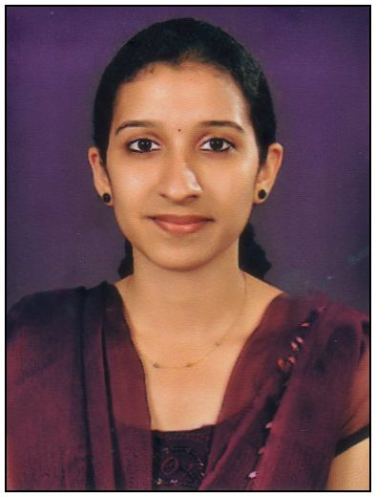
Deepthi.303441@2freemail.com

Name: Ms. Deepthi

Looking forward to be a part of growing organization and to work with full enthusiasm and with the maximum output of the effort applied and to excel in the professional field and help the organization to achieve the desired goal.
Areas of interest: Diagnostic Audiology, Voice

WORK EXPERIENCE
- Worked as Audiologist and Speech Language Therapist at Little Flower Hospital and Research Centre, Angamaly, Kerala (From August 17th 2015 till August 16th 2016)

EDUCATIONAL QUALIFICATION
Course | College/ University | Year | Marks
M.Sc.Audiology & Speech Language Pathology (MASLP) | Kasturba Medical College, Mangalore,Manipal University. Recognized by Rehabilitation Council of India (RCI). | 2013- 2015 | Second Class
B.Sc: Audiology & Speech Language Pathology (BASLP) | Father Muller College Of Speech and Hearing, Mangalore University. Recognized by Rehabilitation Council of India (RCI). | 2009- 2013 | First Class
Higher Secondary Examination: | St. Kuriakose CBSE Senior Secondary School, Kaduthuruthy, Kottayam | 2007-2009 | First Class with distinction
High School Education: | Bappuji Central School, Kunnappilly, Kottayam | 2004-2007 | First class with distinction

EXPERIENCE
BACHELOR’S CLINICAL EXPERIENCE:
Internship (Training Program): Worked in the following places as an Intern during the year
2012-2013 as part of pursuing the Bachelor’s Degree.
NIMHANS, Bangalore
COMDEALL Trust, Bangalore
ManipalCollege of Speech and Hearing, Manipal

OUT REACH PROGRAMMES :
Participated in several Screening Camps organized in and around Dakshina Kannada and Udupi Districts
Attended various conferences on, national, state and regional level.

POST GRADUATE CLINICAL EXPERIENCE:
2013 – 2015: Kasturba Medical College, Mangalore.
Postings
Wenlock government hospital, Mangalore: For audiology and speech language pathology.
Areas of interest:Diagnostic Audiology, Voice
Language Known:Malayalam, English, Hindi, Kannada

ACHEIVEMENTS
- Certified Life Time Member of Indian Speech And Hearing Association. (ISHA Life Membership
- Rank holder in the fifth & sixth semester BASLP final examination conducted by Mangalore University in December 2011/May 2012.

RESEARCH PUBLICATIONS
- Presented paper on “Test Retest Reliability of psychophysical procedures for threshold estimation” for 33rd annual conference of Indian association of Biomedical Scientists & An International symposium on “Recent Trends & advances in Biomedical research –An integrated approach” held by NITTE University, Mangalore in November 1-3,2012.
- Co-author for the paper entitled “Speed of swallowing in healthy aged individuals-A new screening tool for Dysphagia” presented for the 47th ISHACON held at Manipal, Karnataka, India, on 1st - 3rd January, 2015.
- Successful completion of Post graduate dissertation titled “Relationship of consonant perception with auditory processing and working memory capacity” 2015.

Declaration
I do hereby declare that all information given above is true to the best of my knowledge

