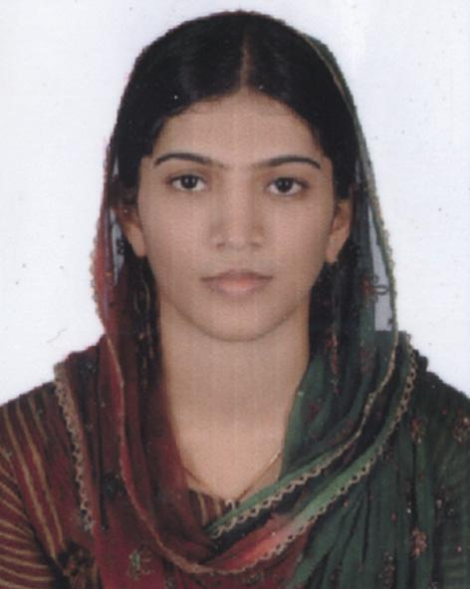

RISLATH.

Email Id: rislath.303669@2freemail.com

PROFESSIONAL OBJECTIVE

To built a career in challenging environment, an opportunity to execute my management skills in a dynamic organization and to crystallize the best of me achieving objectives.

PROFESIONAL EXPERTISE

Manage all petty cash and office supply expense accounts

Establish customer credit lines and set up credit accounts with vendors. Excellent time management and leadership skills.

Confident, self driven, dynamic and loves to learn

ACADEMIC CREDENTIALS

Bachelor of Science – [Chemistry] 74%Calicut University, 2008 Bachelor of Education – Calicut University, 2010

COMPUTER SKILL

MS-Office: - MS-Word, MS-Excel, MS-Power Point, MS-Outlook. Internet Browsing & Surfing

PROFESIONAL EXPERIENCE

Worked as a Teacher in Girls Higher Secondary School in Kerala. India 2009-2010

PERSONAL PROFILE

Date of birth

: 16/04/1989

Sex & marital status

: Female &married.

Nationality & Religion

: Indian & Muslim

Visa Status

: Husband Visa

Languages Known

: English, Hindi & Malayalam

DECLARATION

I hereby declare that the above-furnished information is true to the best of my knowledge. I promise you that I will be a Dynamic Personality who is very truthful and loyal to your company.

