APPLICANT CURRICULAM VITAE
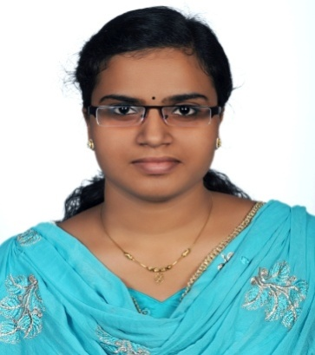
Personal Details:
Name | Stimmy
Age&Date of Birth | 25, 7/03/1991
Marital Status | Single
Nationality | Indian
Religion & Caste | Christian
Email id | Stimmy.303835@2freemail.com

Language Details:
First Language | Malayalam
Other Language | English,Hindi,Kannada

Professional Qualification:
Qualification | Institute | Board | Year
B.Sc. Nursing | Karavali college of nursing science, Mangalore | Rajiv Gandhi university of health science, Bangalore,Karnataka | 2008-12

Academic Qualification:
Qualification | School/College | Year | Results
S.S.L.C | Holy family girls high school ,Angamaly | 2005-06 | Passed
Plus two | Govt higher secondary school Manjapra | 2006-08 | Passed

Work experience:
Period | Designation & Institution | Nature of work
02-8-2013 to  04-12-2015 | Staff nurse  Jehangir hospital(NABH accredited ),Pune,Maharashtra,India | Intensive care unit & Accident and emergency
15-12-2015 to  15-06-2016 | Staff nurse  Moonjely medical center,Angamaly,Kerala,India | Medical ward

Equipments familiar with:
- BP Instrument
- Syringe pump
- ECG mechine
- Suction mechine
- Cardiac monitor
- Pulse oxymeter
- Glucometer
- Oxygen cylinder
- Nebulizer
- Ventilato

Duties / Responsibility:
- Admission and discharge of patients
- Attending to the nutritional needs of patients and their activity of daily living
- Administration of medications and IV therapy
- Maintaining personal hygiene and comfort of patient,provide psychological support
- Recording vital signs
- Handling different types of life threatening situations
- Periodical assessment of the disease condition
- Carry-out routine investigation
- Observe change in patient's condition
- Unconscious patient's care
- Naso-gastric tube insertion and suction
- Nebulization & oxygen administration
- Perform catheterization and care
- Care of ventilator patients
- Perform neurological assessment of the patient (including GCS)
- Implementing the patient focused nursing care plan
- Assistance for intubation, centerline
- Administration of blood and blood products
- Hemodynamic monitoring
- Emergency drug calculation
- Handling of advanced equipments
- Airway management including tracheostomy care
- Care of arterial lines
- Attending the code blue calls
Additional information:
I am optimistic and believe that is stepping stone for success.I am confident and never give up before I achieve the goals.
interests:
I use to spend my leisure time by listening to music or watching TV

Declaration:
I hereby declare that the above information are correct and complete to my knowledge

Date:

