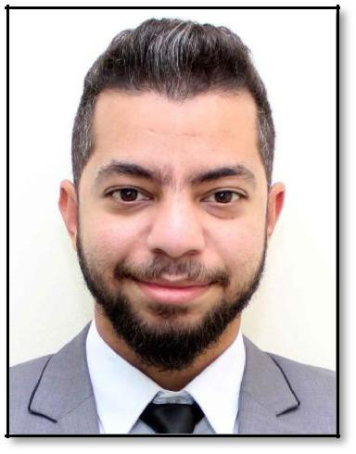
BASSAM
BASSAM.304336@2freemail.com

Objective:

Seeking a job in a professional and dynamic organization where I have chance to apply my skills and acquire knowledge along with the right tools to increase the present value of my organization and consequently myself.

Education:

- Graphics Diploma from "Future Academy" in July 2012.

- Bachelor of Mass Communication, Department Of Journalism from "Akhbar El-Yom Academy" in May 2011.

Experience (4 years and 6 months):

- Worked as a “Graphic Designer/Social Media Specialist/Photographer” at “Al Jaber Optical” from March

2016 till September 2016 in Dubai, UAE.

- Worked as a "Graphic Designer/Social Media Specialist/Photographer" at "Alwan Company" from September 2014 till November 2015 in Cairo, Egypt.

- Worked as a "Graphic Designer and Marketer" at "Zayed Pyramids Advertising Agency" from July 2012 till August 2014 in Cairo, Egypt.

- Worked as a "Photographer and Advertising Agent" at "El Ahram Newspaper" from July 2011 till June 2012 in Cairo, Egypt (Temporary Internship).

Computer Skills:

- Proficiency in using Adobe Graphic package (Photoshop, Illustrator, and InDesign).

- Proficiency in using MS Office (word, excel, power point, and outlook).

- Ability to use all internet tools (browsing, surfing, emailing, etc.).

- Ability to interact with Database systems.

Language Skills:

• Arabic: Mother Tongue

• English: Fluent

Personal Skills:

- Creativity - Excellent oral and written communication skills

- Working Under pressure - Teamwork

- Willingness to learn - Problem solving

- Sociable - Negotiation skills

- Self-Confidence - Analytical ability

- Time Management - Numeracy

- Leadership - Flexibility

Personal Information:

- Date of Birth: 14/04/1990

- Visa Status: Transferable Employment Visa.

- Availability to join: Immediately.

References available upon request

