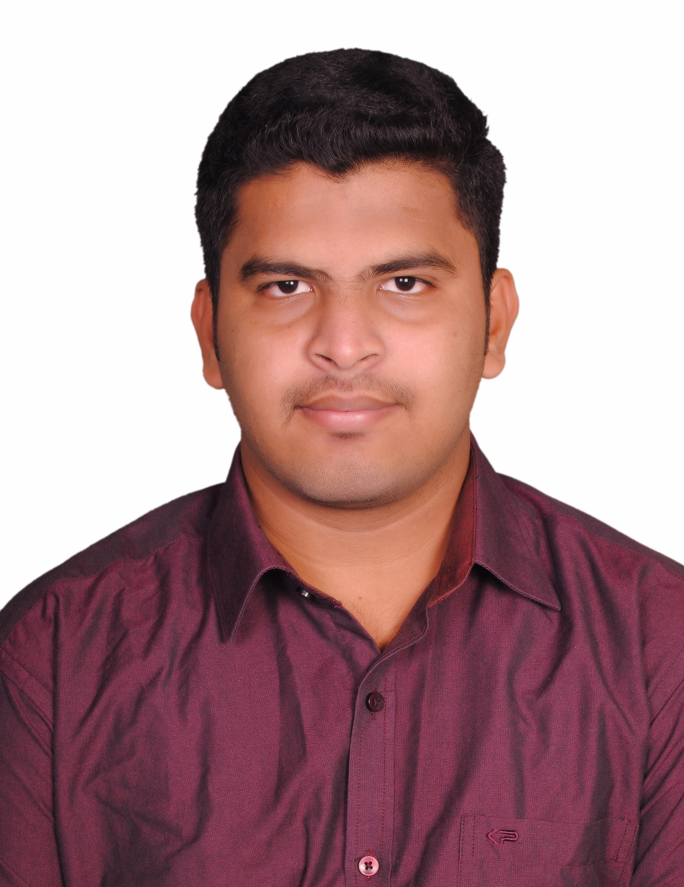  ABDUL RAHMAN T.A  B.E Civil Engineering  PERSONAL DATA  Father Name T.A.ABDUL KATHAR  Date of Birth 14th November 1993  Sex Male  Nationality Indian  Religion Muslim  Material Status Un married  VISA DETAILS  Visa type Visit Visa | Click to send CV No & get contact details of candidate    CV NO:1826466  RESUME  OBJECTIVE  To compete the challenges in the organization with confidence, skill, ability, proficiency and hard work to achieve the position of professional satisfaction.  EDUCATION  BACHELOR OF ENGINEERING  - Year of Passing : 2015  - Percentage of Marks : 6.8 CGPA  - Board/ University : Anna University, Chennai.  - Branch : Civil Engineering.  - Institution Name : Aalim Muhammed Salegh College of  Engineering, Chennai., INDIA.  HSC  - Year of Passing : 2011  - Percentage of Marks : 71.3%  - Institution Name : Gill Adarsh Matriculation Higher Secondary,  School, Chennai., INDIA.  SSLC  - Year of Passing : 2009  - Percentage of Marks : 69%  - Institution Name : Gill Adarsh Matriculation Higher Secondary,  School, Chennai., INDIA.  QA/QC WELDING INSPECTION  - ASNT Level ll (RT, UT, MPT, LPT)  - WELDING INSPECTION THEORY & PRACTICALS  - BASIC PIPING ENGINEERING  WORK EXPERIENCE  - Company Name : Naga’s Civil Engineering Contractors ,Chennai  - Duration : 6th July 2015 to 8th August 2016  INTERNSHIP PROGRAM  - Company Name : Bharath Building Construction Pvt.Ltd.  - Duration : 20th December to 26th December 2012  - Company Name : Chennai Port Trust  - Duration : 17th June to 21st June 2014

CAD PACKAGES
- Auto CAD 2014
- Staad pro
- Auto cad Revit 2015

LANGUAGES KNOWN
- Tamil – Read, Write and Speak
- English – Read, Write and Speak

PROJECT
- Title : Evaluation and comparison of Sugarcane Bagasse Ash (SCBA) and Rice Husk Ash (RHA) as a partial replacement of cement

Duration : 3 months

PROJECT DESCRIPTION
- My project is to compare and evaluate the compressive strength and split tensile strength of Rice Husk Ash (RHA) and Sugarcane Bagasse Ash (SCBA) with different percentage of cement replacement. To produce concrete with reduced environmental impact. The pollution is controlled and it is found to be eco-friendly. The contamination of ground water from RHA and SCBA reduced. The demand for cement is also reduce. It is found to be economical and cost of the material is reduced up-to 10% for 1m³

CURRICULAR ACTIVITIES
- Won 1st place in kabaddi in zonal of year 2011 and represented for Chennai in “A” grade tournaments.
- Actively participated in various sports activities for inter school.
- Executive member of sports committee in Gill Adarsh Mat Hr Sec School..
- Executive member of event organizing committee in Aalim Muhamed Salegh College of Engineering for college functions.
- Participated in the 7days (1-03-2013 to 7-03-2013) special camping program in National Service Scheme (NSS) conducted by Anna University and also completed two year service in NSS during 2011-2013.

DECLARATION
I (T.A ABDUL RAHMAN) hereby declare that the above-mentioned statements are complete true to the best of my knowledge.

PLACE : Al Ain, UAE
(T.A.ABDUL RAHMAN)

