SARAH
SARAH.304761@2freemail.com 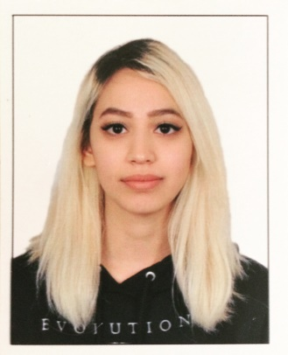

______________________________________

Personal/Contact Information
D.O.B.: March 9, 1992
Nationality: Filipino Syrian

Educational Qualifications
High School Diploma, SABIS International School of Choueifat – Ruwais. (June 21, 2010)
BA in English, Abu Dhabi University (ADU), UAE. (August 9, 2015)
Experience
- November 11-13, 2011: Usher/hostess at F1 2011 Abu Dhabi Grand Prix with ClassAct. Scanned passes, welcomed guests, gave out earbuds, and general help (answering questions, giving directions, etc.)
- Circa 2012 – present: Freelance artist. Taking commissions i.e. creating artwork and selling them to clients.
- January 2012-August 2015: Associate editor for the university's magazine, ADU Voice. Copywriter, edited articles for grammar, spelling, and appropriate content before publishing.
- April 5-6, 2013: Exhibiting artist at MEFCC Artist Alley, Dubai. Displaying and selling artwork.
- April 3-5, 2014: Exhibiting artist at MEFCC Artist Alley, Dubai. Displaying and selling artwork.
- April 9-11, 2015: Exhibiting artist at MEFCC Artist Alley, Dubai. Displaying and selling artwork.
- April 19 – June 6, 2015: Administrative assistant intern for IELTS – ADU. Entered applicants’ data into the system, stamped and sealed IELTS certificates of candidates, worked at the reception for an hour every working day to help applicants apply for IELTS and handing over the certificates, as well as invigilator at IELTS exams.
- May 5, 2016 – present: Signed artist with The Message as agents for selected artwork.
Events
- February 20-21, 2015: Street artist at Street Nights, Dubai. Painting walls alongside other established and emerging artists.
Exhibitions
- November 24, 2013: ADU’s UAE National Day Art Competition and Exhibition. Abu Dhabi, UAE.
- October 1-31, 2014:“Mind Your Hashtags” group art exhibition curated by Henosis. Abu Dhabi, UAE.
- May 5, 2016: “Visions” group art exhibition curated by The Message.
Achievements
- April 23, 2013: Participated in The First United Arab Emirates Undergraduate Student Research Competition.
- Fall 2013/14: Outstanding performance in the College of Arts and Sciences.
- Spring 2013/14: Outstanding performance in the College of Arts and Sciences.
- Spring 2014/15: First place in Mothers’ Day Art Competition.
Publications
- Featured on Klei Entertainment’s “Don’t Starve” website for Fan Art under the alias “Sarah Re”. Rollins, C. (June 28, 2013)https://www.kleientertainment.com/games/dont-starve/fan-art
Skills
- Administrative skills
- Communication skills
- Bilingual, fluent in both English and Arabic, written and spoken
- Translation
- Education for ESL
- Teaching/tutoring
- Copywriting
- Creative writing
- Writing and editing
- Microsoft Word
- Experience with social media
- People skills - children, teens, adults
- Confidentiality
- Easy to work with
- Time flexible
- Interpersonal skills
- Intrapersonal skills
- Traditional art
- Moderate knowledge on art history, as well as modern art
- Basic architecture and design (studied a few architecture courses during freshman year)
- Art
- Painting
- Drawing
- Illustration
- Illustration – storyboarding
- Fine art – galleries

