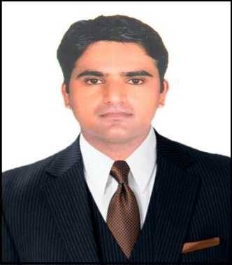

Amit
amit.304831@2freemail.com
Civil Foreman

Objective
Seeking a challenging career opportunity in a reputed company where I can harness my technical skills, work experience and creative towards making significant contribution to the growth and development of the company and there by develop myself.

Career Profile

I am a Diploma in Civil Engineering and having good professional experience in Supervision and inspection of site work assuring quality of works for high-rise residential and commercial project in gulf as well as India. I have the capacity of monitor to the confidence to lead a team and the personality to pass on skills and experience to junior staff. I am experienced in the preparation of daily work schedules, arrangement of resources such as men, materials etc.

 | Education
Bachelor of Arts  Seth G.D.S.B.Patwari College, Bagar  Rajasthan, India  2008 |  | Diploma in Civil Engineering  Shridhar University,Pilani  Rajasthan, India  2012

Language Known

Hindi, English, Rajasthani

Experience
I have 4+ years on site experience in construction of high-rise buildings & Villa Projects.
- Sood Associates Pvt. Ltd., INDIA – (Junior Site Engineer) 1.5 Years
- MS Construction L.L.C, DUBAI- (Finishing Foreman) 5 Months
- Urbacon Trading & Contracting W.L.L, QATAR - (Civil Foreman) 1 Years
- Mira Construction Pvt. Ltd., INDIA - (Junior Civil Engineer) 1.9 Years

Duties

- Main Responsibilities were coordinating & supervising the site.
- Getting the work done as per engineer's instruction.
- Preparing all types of reports on paper sheets.
- Collecting samples of materials to be approved.
- Preparing work inspection request provide by engineers.
- Gathering all approved inspection of work & submittal of materials.
- Mentoring the contractor respect the rules of health & safety.
- Report the activity on site to engineer.
- Visiting sites & gathering necessary information such as site conveniences.

 | Key Skills
Professional Skills  - Positive attitude towards work and great ability towards result oriented output  - Good Knowledge of drawings, good Communication Skills.  - Self-confident and can perform impressively under time and pressure.  - Able to carry out work smoothly in multicultural environment.  - Site Supervision, Hardworking, Sincere & Honest |  | Computer Skills  - Basic Knowledge of MS Office.  - Basic Knowledge of Operating Systems.

Declaration

I hereby assure that the above details are true to the best of my knowledge. I also understand that any discrepancy found in the above information will render me liable for cancellation of debarment.

