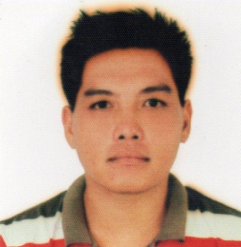
NELSON
Email Address: nelson.304860@2freemail.com
Contact # C/o 0505891826

To gain more experience and learn to adapt challenges in my work experience.

MUNICIPALITY OF OBANDO PROVINCE OF BULACAN (OJT)
Data service filer/Admin. Encoder
- Prepare for the upcoming meetings and take down note for the progression of meetings.
- Arranging monthly news bulletin and memorandum
- Preparing corresponding documents invoice including material for bidding
PROVINCIAL GOVERNMENT OF BULACAN
(GENERAL REVISION OF REAL PROPERTY ASSESMENT AND CLASSIFICATION)
Field Inventory Team

- Updating real property land or building
- House to house survey of what is the establishment or the property been developed after a year

JOLLIBEE
Ali Mall Branch Araneta Cubao,Quezon City
Stock clerk

- Preparing the product that will use in the morning
- Cleaning the stock area
- Creating product inventory
- Creating FIFO(first in-first out)

COCA-COLA COMPANY (FEMSA)
Brgy.sto nino, meycuayan, bulacan
STOCK COORDINATOR/CHECKER

- CREATING FIFO(first in-first out)
- Checking the inventory stock of the plant
- Creating inventory stock before and after shift
- Reporting actual stock vs. system stock

SM HYPERMARKET
SM NORTH EDSA QUEZON CITY
RDU CLERK

- Check the expiry date and quantity
- Verifying item before receiving
- Released the return purchase order(P.O) and (B.O.) bad order

NEW REAL SHELL SERVICE STATION
Tigbao, Tacloban, Leyte
Area Supervisor

- Supervising personnel regarding to the shifting schedule
- Receive incoming deliveries
- Maintaining and supervising product quality and quantity and reports

EDUCATIONAL ATTAINMENT

ELEMENTARY: Mababang Paaralan Ng Tawiran
Tawiran,Obando,Bulacan

SECONDARY: Colegio De San Pascual Baylon
Pag-Asa,Obando,Bulacan

TERTIARY: Bulacan State University
Malolos,Bulacan

