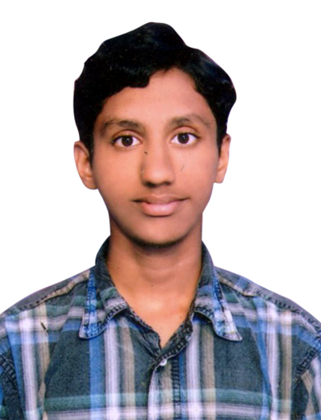
CURRICULUM VITAE

Venkata

Venkata.304879@2freemail.com

OBJECTIVE

To obtain a challenging and responsible position, where I can learn and mould up a career and contribute for the success of the organization using my skills and hard work.

ACADEMIC QUALIFICATION

- S.S.C from Board of Secondary Education A.P, in the year 2006 in H public school, Machilipatnam, Andhra Pradesh, INDIA.
- Diploma in Electronics and Communication Engineering in the year 2011 in S.V.L.Polytechnic College, Machilipatnam, Andhra Pradesh, INDIA.

COMPUTER SKILLS

Operating System | M.S.DOS, Windows98, Millenium, XP, Vista, 07, 08, 8.1, 10, Linux, Ubuntu.
Hardware & Networking | Complete installation, Maintenance & Troubleshooting ofPersonal Computers and its Peripherals.
Commands | All RUN commands, Internal and External commands.
Basic knowledge | Microsoft word, Excel, Power point, and M.S.Suits, Typing perfect.

TECHNICAL QUALIFICATION

- Diploma in Hardware & Networking from Techno Towers in Machilipatnam, Andhra Pradesh, INDIA.
- Experience in Hardware & Networking in a period of June 2011 to June 2013 in Techno Towers, Machilipatnam, Andhra Pradesh, INDIA.
- Diploma in M.C.S.E (Networking Administration) from Techno Towers in Machilipatnam, Andhra Pradesh, INDIA.

EXPERIENCE

- ATANA HOTEL Engineering department as Handyman and acts as an Engineering Co-ordinator in engineering department at Dubai Internet City, Tecom, DUBAI from 29 July 2015 to till date.
- Experience in Hardware & Networking in a period of June 2011 to June 2013 in Techno Towers, Machilipatnam, Andhra Pradesh, INDIA.

PC HARDWARE

I am proficient in the following areas and have a good experience in handling assembled and proprietary design.
- Assembling, disassembling & upgradation of desktops.
- Installation & configuration of various IDE & SCSI devices.
- Installation of device drivers, service packs & patches.
- Installation & configuration of desktop peripherals (printers, scanner, modem, web cam, all-in-one devices, wireless infrared devices etc.).
- Installation & configuration of software packages (Microsoft packages, adobe packages, utilities etc.).
- Optimizing & fine-tuning the PC for best performance by using various system tools (virtual memory, services, registry editor, disk management, disk clean, disk defragmenter, system backup & restore, scheduled tasks, device manger).
- Adjust the system performance by editing & configuring various system files.
- Maintaining of server & client administration.

TROUBLE SHOOTING

- Diagnose & interpret various BIOS messages & beep codes.
- Diagnose & troubleshoot hardware related issues.
- Diagnose & troubleshoot O.S related issues by using system tools & command line utilities.
- Recover & restore the corrupted O.S by using bootable disk, system restore procedure, recovery software provided by respective company etc.& ensure its smooth functioning.
- Recover & restore PC from virus attacks (rescue disks) & ensure its smooth working.
- Diagnosing & trouble shooting desktop peripheral related issues.
- Diagnose of motherboard problems.
- All types of Printer repairing and toner cartridge refiling.

PASSPORT DETAILS
Date of Issue : 07-09-2012
Date of Expiry : 06-09-2022
Place of Issue : Hyderabad
Visa Status : Employment Visa

PERSONAL DETAILS
Date of Birth : 27-03-1991
Languages known : English, Hindi, Telugu
Nationality : Indian
Marital status : Unmarried
DECLARATION

I here by declare that all the particulars furnished above are true to the best of my knowledge.

