CURRICULAM-VITAE
ABDULLAH

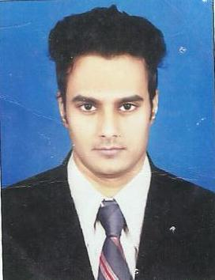

Email: Abdullah.304927@2freemail.com

B.TECH (CIVIL ENGINEER)

POST APPLIED FOR : CIVIL ENGINEER/ SITE ENGINEER

OBJECTIVES:
Seeking for a challenging position as a Civil Engineer, where I can use my planning, designing and overseeing skills in construction and help grow the company to achieve its goals.
JOB EXPERIENCE : |  | Total 02 Years
➢ Company Name | : FEM Constructions (India) Pvt. Ltd. (Mumbai)
Position | : | Civil Engineer / Site Engineer
Duration | : | From 25.05.2015 to till date

JOB RESPONSIBILITIES :
- Planning and Execution of works as per design & drawings.

- Preparation of daily, weekly, monthly reports on work progress & evaluating as per the planned schedules.

- Supervision of the working labour to ensure strict conformance to methods, quality and safety.

- Checking the quality of work and construction activity as per drawings.

- Prepare volumetric drawing in AutoCAD 3D for quantity calculation.

- Making drawing for construction methodology with alternative methods according to different site conditions.

- Checking the construction bills and Manage all site execution as per construction schedule.

- Co-ordination with the client and subcontractor.
TECHNICAL SKILLS:
- AutoCAD (2009, 2010 & 2013) with sound knowledge of 2D and 3D modeling

- AutoCAD CIVIL 3D 2013

- MS-Office, window 7 & XP

- Internet & Outlook ability

PROFESSIONAL SKILLS:
- Managing part of construction projects.

- Overseeing building works.

- Supervising contracted staff.

- Insuring project meet agreed specifications budgets and time scales.

- Checking and preparing site reports, design and drawing
ACADEMIC QUALIFICATIONS:
➢ B. Tech Civil Engineering |  | : Rajasthan Technical University Kota, India
➢ | HSC (High School) | : RBSE Board
➢ | SSC (Intermediate) | : Rajasthan Board, Ajmer (India)
PASSPORT DETAILS

 | Place of Issue | : | Jaipur
 | Date of issue | : | 11/12/2015
 | Date of expiry | : | 10/12/2025
 | PERSONAL DETAILS :
 | Date of Birth: |  | 03-May-1995
 | Martial Status: |  | Unmarried
 | Religion |  | Islam
 | Language Known: |  | English, Urdu, Hindi
 | Nationality: |  | Indian

Declaration:

I hereby declare that the above particular are true and complete to the best of my knowledge and belief. I highly obliged of positive response in this direction from your side.

