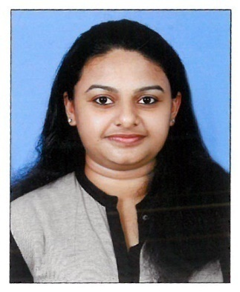
SOPHY
Sophy.305007@2freemail.com

CAREER OBJECTIVE :

To work efficiently for the organization so as to faster the development of the organization growing by learning from the existing system.

PERSONAL PROFILE :
- Completed Master Degree in Computer Application from Garden City College Bangalore ,Karnataka in 2013-2016 and have 8 month experience as an Programmer Trainee.
- Completed Bachelor Degree in Physics from Mahatma Gandhi University Kerala in 2010-2013.

AREA OF EXPERTISE :
- PHP, PHP Framework(Codelgniter), MySQL, HTML, MS Office, Tally.

PROFESSIONAL QUALIFICATION :
YEAR | INSTITUTE / COLLEGE | COURSE | PERCENTAGE
2013-2016 | GARDEN CITY COLLEGE,  BANGALORE. | MCA | 69%
2010-2013 | BISHOP ABRAHAM MEMORIAL COLLEGE, THURUTHICADU | B.Sc PHYSICS | 57%
2008-2010 | CMS HIGHER SECONDARY SCHOOL, MALLAPPALLY | PLUS TWO (SCIENCE) | 63%
2007-2008 | CMS HIGH SCHOOL, NEDUNGADAPPALLY | SECONDARY SCHOOL LEAVING | 62%

PROFESSIONAL EXPERIENCE :
- Worked as an Programmer Trainee in Golabsoft Technology Services LLP from 01/02/2016 to 30/10/2016.

RESPOSIBILITIES :
- Design implement web applications, prototypes, user interface and websites for clients.
- Participating in a team-oriented environment to develop complex web-based applications.
- Provide technical training support to client when necessary.
- Engage in problem definition solution implementation according to clients needs.
PERSONAL STRENGTH :
- Self –Confident
- Good Communication
- Good understanding Capability
- Problem Solving
- Ability to work in team as well as individual

LANGUAGE PROFICIENCY :
- ENGLISH , HINDI, MALAYALAM.

DECLARATION :
I Ms. Sophy hereby declare that the above all statements are true and correct to the best of my knowledge and believes.

