CURRICULAM VITAE
NAME :FRAYAL 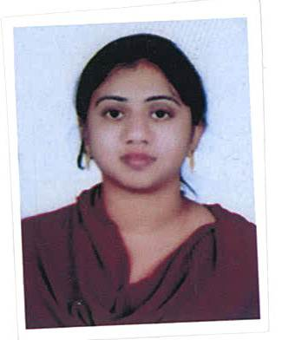
MAIL: frayal.305011@2freemail.com
CAREER OBJECTIVE:
Looking for an opportunity to associate with a progressive organization to where I can leverage my broad technical skills, analytical ability and commitment to perform quality work towards the growth of the organization.
QUALIFICATIONS
Professional Education:
- CERTIFIED IN IATA FOUNDATION FROM KUONI ACADEMY
- CRS (AMADEUS )
EDUCATION
Degree / Diploma | University / Board | Year of Passing | Percentage /  Class
IATA FOUNDATION COURSE | KUONI ACADEMY | 2015 | PASSED
INTERMEDIATE | BHAVITHA JUNIOR COLLEGE | 2009 | 70.3%
SSC | ST MARYS VIDYALAYA | 2007 | 82%

WORK EXPERIENCE
- Worked as a travel consultant in TRICKY TRAVELLER as a Travel Reservation Executive consultant for 01 year (03Nov2014-23Dec2015)
- Worked as a Travel Consultant in RiyaTravels , Hyderabad as Travel Consultant. (01Feb2016-27Aug2016)
TECHNICAL QUALIFICATION
- Computer Knowledge : Working knowledge in the use of Windows, MS Excel and the internet.
PERSONAL SKILLS:
- Very good in communication skills
- Comprehensive problem solving ability backed with a will to learn and grow
- Active listener – Willing to learn and listen.
PERSONAL PROFILE:
NAME : FRAYAL
DOB : 08MAR1991
NATIONALITY : INDIAN
RELIGION : MUSLIM
EDUCATION : INTERMEDIATE
MARITAL STATUS : MARRIED
LANGUAGES : ENGLISH,HINDI,URDU,TELUGU.

DECLARATION:
I assure your Excellency that the information given above is true to the best of my knowledge and belief. If provided an opportunity, I will utilize it with all my determination to be a committed professional dedicated to the cause of the organization.
Place: SIGNATURE

