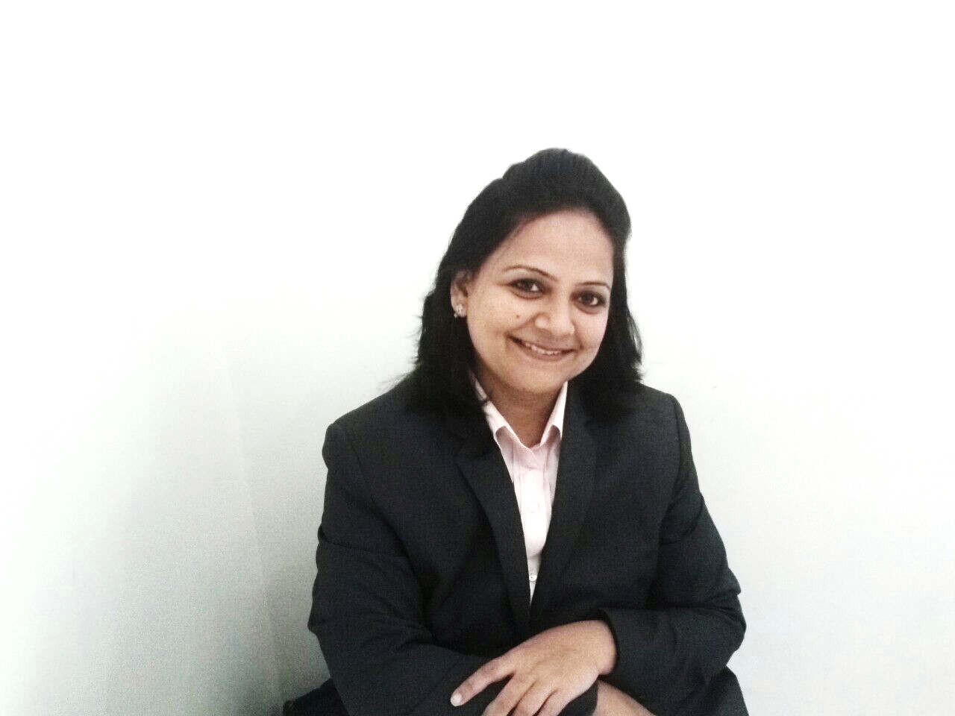

***SURUCHI***

**CAREER OBJECTIVES**

To utilize the education, expertise and experience to its true potential in establishing successful career in Pharmaceutical industry and contribute in taking the brand to a higher level. I strongly believe this is possible with a great team work and staying focused in order to achieve any organizational mission.

**PROFESSIONAL JOURNEY**

**United Chemicals of Belgium (UCB)**/ New Delhi, India / Sept 2007- Jan 2011

UCB is multinational biopharmaceutical company headquartered at Brussels. It’s a 3.3 billion Euros company primarily dealing into anti-epileptic and anti-inflammatory products.

*Field Sales Officer*

KEY ACHIEVEMENTS

* Was instrumental in increasing the distributor base by 30% in first year of joining in order to make sure that the products are in reach of maximum retailers. In 3 years increased the distributor base by 400%
* Increased the sales of Nootropil (the highest selling product) by 100% i.e. from 1 million INR to 2 million INR per month.
* Made Xyzal and Zyrtec the highest selling brands in the assigned territory. The difference between the Xyzal and the second best selling brand was little above 30% in terms of INR value.

**NICHOLAS PIRAMAL INDIA LTD**/ New Delhi, India/ July 2006- August 2007

One of the largest drug manufacturer company in India with over 200 products.

*District Sales Manager*

KEY ACHIEVEMENTS

* Part of Launch team in Delhi. Successfully launched the brand in assigned territory.
* Built a strong distribution network by bringing reputed top distributors on board.
* Started from no base to 1, 00, 000 INR per month sales.
* Made Lebact (Levofloxacin) one of the top selling brands in the assigned area. Within 6 months started selling 50 boxes of Lebact per month from absolute zero base.
* Made Finecef-T (Ceftriaxone) available in most of the nursing homes in the assigned areas. Lebact and Finecef became the key contributors in the assigned area within 6 months.

[Suruchi.305036@2freemail.com](mailto:Suruchi.305036@2freemail.com)

**CORE COMPETENCIES**

* Relationship building Skills
* Analytical skills
* Market research
* Mentoring

**EDUCATION**

Diploma in Pharmacy

**LANGUAGE PROFICIENCY**

English – Fluent

Hindi – Native

Punjabi–Fluent

**DRIVING LICENSE**

INTENATIONAL DRIVING LICENSE

UAE DRIVING LICENSE: Applied for

**MARITAL STATUS**

Married

**EXPERIENCE (CONTINUED)**

**SUN PHARMACEUTICALS** (Anti-Diabetic Division)/New Delhi, India / June 2004- June 2006

A multinational pharmaceutical company Headquartered in Mumbai with a huge range of products having multiple divisions.

*Sales Officer*

KEY ACHIEVEMENTS

* Brought almost dead and most unstable territory back to track by selecting right product mix and aggressive campaigns with increased frequency of visits to the medical practitioners of the area. This helped in bringing sales up by 5 times (2, 00, 000 INR to 1 million INR) in just 6 months.
* Became the most valuable player by increasing Repace(Losartan) sales from merely 25 boxes to 275 boxes in a span of 6 months in the designated region.
* Played key role in arranging CMEs on regular basis by inviting top doctors in the area and promoted the products there. This helped to boost the sales by significant percentage month on month.
* Played instrumental role in training the new joiners.

**APEX LABORATORIES**-New Delhi, India /Sep 2001- May 2004

Chennai based Pharmaceuticals Company known for Zincovit. COMMONLY CALLED AS ZINC COMPANY.

*Professional Service Representative*

KEY ACHIEVEMENTS

* Always got acknowledged for achieving the highest sales in the assigned territory.
* Was the “Most innovative team member” in terms of finding new resources to increase the sales.
* Was instrumental in organizing regular CMEs/events/activities in the assigned territory.
* Represented the organization in many national level medical conferences/CMEs

**SURUCHI**