CURRICULUM VITAE
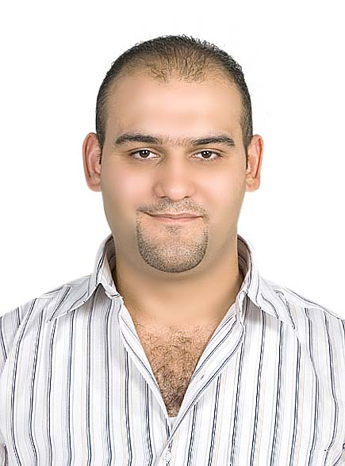

Hussam
Dubai– U.A.E.
Email: hussam.305186@2freemail.com

Objective:
Seek challenging roles in on organization that helps me to make strong contributions to organizational goals through perseverance, hard work and continued developed of my personal skills within Engineering Field.

Personal Information:
Date of Birth : 25/07/1982
Nationality : Syrian – Damascus.
Marital Status : Married.
Sex : Male.
Visa Status : Employment
Driving License : Valid U.A.E. Driving License.

Educational Qualification

- Licentiate in Civil Engineering Assistant Graduate – 2004.

PROFESSIONAL AFFLIATIONS
 |  | 1- |  | Auto Cad Program
 |  | 2- |  | MS Project
 |  | 3- |  | MS Office (word , Excel)
 | COURSES & AWARDS
 |  | * | Participation in a course in AutoCAD with Engineers Association
 | MEMBERSHIP
 |  | * | Member, Syrian Order of Engineers
WORK EXPERIENCE
Organization : Shadid Engineering Consultants, Dubai - UAE
Position : Civil Inspector
Project :152-249 villas phase 1 – package 4 & 6 _ al furjan
Project Value : Around 320 million AED.
Perio Duration : From January Till Date

 | * | Following up progress at site
 | * | Following daily activities at site and arrange site instructions
 | * | Inspect civil work structural and finishing
 | * | Follow and monitor the site activities including issue NCR and SI
 | * | Handle all inspection request
 | * | Reviewing, approve/comment shop drawings, materials submittals, program of work

Organization : ACTCO General Contracting Company
Position : logistic and materials engineer.
Project : 15 migd swro desalination at al ghlilah, ras al khaimah (fewa plant).
Project Value : Around 320 million AED.
Period : April 2011till 2015

Responsibility:
- Bring materials for the project and choose classed as appropriate.
- Coordination mechanisms and equipment for the project.
- Coordination between project management and consulting engineer.
- Coordination between the administration of the project and sub-contractors

Organization : ACTCO General Contracting Company
Position : Site Engineer
Project : University Hospital Sharjah and Dental Hospital.
Project Value : Around 500 million AED.
Period : April 2007 –April 2011.

Responsibility
- Foundation piling & draft slab
- Major Construction building services and infrastructure.
- Commissioning and handover.
- Oversee the excavation and backfill.
- Oversee the work of steel and carpentry.
- Supervision at night in certain periods of the night for concrete work.
- Follow up of the finishing work and requirement
- Follow of the constructors and worker of the company.
- Follow up and coordination with the construction manager.
- Daily work of the required work achievement.
- Delivery of the consultant Engineer in the site.
- Experience to know the types of finishing Materials.
- Put forward ideas and facility in the action plans.
- Coordination to fetch the types of materials for finishing work.

Organization : Pauling Middle East General Contracting Company
Position : Site Engineer.
Project : Falcon City Villa – Dubai- U.A.E.
Period : 01/02/2007 – 28/03/2007
Responsibility
- Follow up Carpentry work and concrete work
- Coordination of the construction manager.
- Delivery of the Consulting Engineer in the site.

Organization : Pauling Middle East General Contracting Company
Position : Site Engineer.
Project : Discovery Garden Project (Mogle) Housing Project 5 floors– Dubai- U.A.E.
Project Value : 390 MillionDH.
Period : 16/01/2006 – 01/01/2007.
Responsibility
- Follow up the Carpentry work & Concrete work.
- Follow the casting in certain day
- The work regular meeting with the crew observes technicians to develop action work.
- Delivery of the Consulting of the Engineering Work.
- Follow up finishing work in the site.

Organization : Pauling Middle East General Contracting Company.
Position : Site Engineer
Project : Discovery Garden Project (Contemporary) Housing Project 5 floor - Dubai – U.A.E.
Project Value : 420 MillionDH.
Responsibility
- Follow up the carpentry work and concrete work.
- Delivery of the consultant work in the site.
- Follow up the finishing work in the site.
- Experience to know the types of finishing materials required for finishing work.
- Coordination with the construction manager.

Organization : Petra General Contracting Company
Position : Supervisor
Project : Residential Village of two floor swimming pool and garden
Responsibility
- Follow plaster, paint & ceramic
- Keep working and technical supervision.

Language Known
Arabic – Mother Language.
English – very good.
Hindi – Little

Declaration:
I hereby certify that all of the information supplies herein true and correct to the best of my knowledge &belief.

