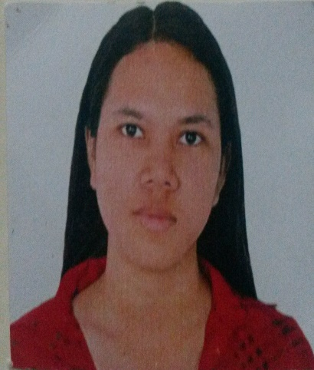
‍‍ Carinan

PERSONAL DETAIL
Email: carinan.305525@2freemail.com
Gender: Female
Nationality: Filipino
Marital Status: Single
Date of Birth: March 19, 1993
Language known: English
Visa Status: Visit Visa
PROFILE STATEMENT
A hard working, responsible and results oriented individual who naturally love to work in a challenging environment that promotes personal and professional growth. A self-motivated and goal driven person who can work efficiently individually or in a group. Eager to learn and adapt diverse ideas and approach required by the company.
ACADEMIC QUALIFICATION
Bachelor of Secondary Education
Major: Biological Science
Bicol University Tabaco Campus 2010-2014
Licensed Teacher
SKILLS AND ABILITIES
- Supervisory experience including effectively leading and motivating a team
- Excellent organizational skills and the ability to work to deadlines
- Excellent written and oral communication skills
- The ability to understand and effectively pass on detailed instructions and progress reports
- A flexible approach to the division of resources and dealing with priorities
- Strong decision making and problem solving skills
- Computer literate, able to use MS word, excel and PowerPoint

EXPERIENCE
sales representative| personal collection | september 2015- july 2016
Order, sell, pay and promote products to every costumer. Also responsible for recruiting franchise dealer.
Duties:
- Helping clients to find home, personal, baby products, apparel, fragrances and health care products that suits to their needs.
- Promote different products to all potential buyer and dealer
- Explain matters clearly to a newly recruit product dealer
team supervisor | philippine statistics authority| august-september 2015
Supervising and ensuring for complete and accurate work of enumerators in their assigned area.
Duties:
- To assist the census office in the coordination, monitoring and management of the Census field operations.
- Ensuring confidentiality and security of census information at all times
- To monitor the progress made by assigned Enumerators through the review of enumerator transmittal forms
- To spot check submitted questionnaires, visitation records, and institutional questionnaires for completeness and quality assurance of his/her output.

Voluntary work
Volunteer teacher (part-time) 2012-2013
New Era University Summer Program
Sharing knowledge to small children 5-7 years old every summer in preparation for the next school year. Facilitate activities and routines inside the classroom.
Duties
  - Writing lesson plans, organizing classroom
  - Facilitate lessons
  - Delivering instruction and maintaining classroom discipline
  - completing teacher’s responsibilities such as assessment and monitoring student’s success
  - handle and understand individual differences of a learner.

I hereby certified that the above information are true and correct.

