Curriculum Vitae
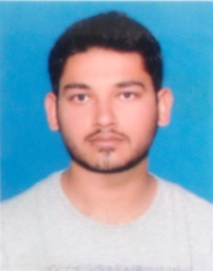
Career object:
To work in a friendly environment and have ability to work as individual
and also with the team and aim for providing best services.
Personal profile:
Name : BASHARAT
Date of Birth : 05-12-1993
Gender : Male
Nationality : Pakistani
Marital status : Single
Religion : Islam
Visa status. : Visit visa valid from 23-10-16
Email ID : BASHARAT.305874@2freemail.com
ACADEMIC Qualification:
Exam | Board/University
METRIC | Rawalpindi Board (2009)
FSC | Rawalpindi Board (2012)
B.COM(IT) | University of the Punjab (2014)
PROFESSIONAL QUALIFICATION
Auto Cad Operator  (Drawing Tools, Drawing Commands, Plotting)  (Duration 6 Months) | Punjab vocational Training Institute Jhelum.
Office Management In I.T  (MS Word, MS Excel, MS Powerpoint, Typing)  (Duration 3 Months) | H.H Computers Jhelum.
Experience:
- 18 Month working experience as an warehouse officer and K.P.O (Key Punch Operator) of NPD PVT LTD JHELUM.
- 4 Month working experience as an computer operator of SHAN FOODS JHELUM.
- 6 weeks working experience as an internee under experienced an qualified staff of ASKARI BANK GTS CHOWK JHELUM.
- 2 Month working experience as an AUTO CAD operator.
Computer skills:
- Complete working and Knowledge of ERP & BIS (Enterprise Resource Planning, Burque Information System) in NPD PVT LTD.
- Complete MS-OFFICE Including Word, Excel, Power Point etc.
- Complete Internet Expertise.
Additional skills:
- Efficient in handling peoples & in team work.
- Cheque book & debit card record maintenance and follow up with customers.
- Time management.
- Office File Maintenance.
- Maintain the Parties Ledger on daily basis.
- Maintain the branch stock position on daily basis.
Banking skills:
- Account opening
- Customers services
- Issuance of Visa Debit Card
Languages:
Complete read, write and speak…,
- Urdu
- English
- Punjabi
Reference:
I will fully furnish on demand & on request.

