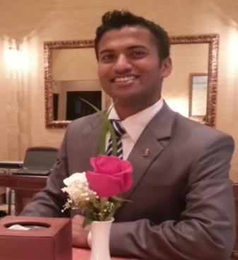
Katheeb
Katheeb.306716@2freemail.com

Objective

I would like to be a part of a well renowned organisation, where I can grow and enhance my hospitality skills, and also impact my leadership achievement in the development of my organisation.

Career Enhancement

Senior Banquet Supervisor & Outdoor catering supervisor
Ritz-Carlton Hotel Doha, Qatar
Oct 1st 2013 Till Present.

Responsible for the smooth and efficient running of the Banquets Operation, Catering & Conference, Meetings & Events in Sharq Village & Spa Operated By The Ritz-Carlton Hotel Company B.V. including staff welfare and the maximizing of sales and profitability. Managing & leading the Banquets operations, and standards ensuring that all staff work and trained effectively leading to a developed workforce. Supervising daily Banquets & Outdoor Caterings operations; assist with menu planning, maintains sanitation standards and assist servers and hosts on the floor during peak meal periods. To direct and work with the food and beverage management team and employee’s to successfully execute Banquets operations strive to continually improve guest, members and employee’s satisfaction and maximize the financial performance in areas of responsibility.

Additional Strength

Seasoned Professional, with Planning, Budgeting, execution, monitoring and resource balancing skills and ability to handle multiple functions and activities in high pressure environment with tight deadlines.
Customer Relationship and satisfaction having prestigious skill to speak to the guest in a warmth and friendly courteous Manner. Guest satisfaction
Ability to handle 1500 pax individually without the manager.
Handling the outdoor catering individually.
Pre site inspection for outdoor catering.
Planning and preparing the checklist.
Ordering of casual labour as per the requirement.
Assigning them in proper allocation as per the table setup.
Briefing them for setup, service, and breakdown as per the BEO (Banquet Event Order).
Training them for loading and unloading of equipment as per the hotel safety standard.
Audion Visual, Graphic Designing.
Employment Summary

Ritz-Carlton Hotels (Doha, Qatar)
Banquet Senior Supervisor Sep 2010 to till
- In charge of Banquet and outdoor catering operation
- Working closer with Director of Banquet
- Focusing Anticipating of guest needs.

Rosewood Corniche Hotels and Resorts (Saudi Arabia)
Lobby Lounge senior waiter Aug 2008 to Aug 2010
- Serving to the guest as per the hotel standard
- Taking in charge in the absence of supervisor
- Building relationship with the guest

Hotel Midtown Pritam (India, Mumbai)
Food and beverage Associate June 2007 to June 2008
Taking care of all the guest need
Personalized service to the customer
Collecting Guest preferences

Educational & Professional Certificate

Master of Business Administration, Alagappa University Chennai, karaikuddi 2014. Distance Education
Bachelor of Hotel Management and Catering Science, Madurai Kamaraj University, Madurai 2003-2006
Diploma in software and hardware computer science-2006

Achievements
Achieved Best employee of the month-2015
- I have been selected as best employee of the month in my department
Achieved 5tar of the quarter -2014
- I have been selected 5star of the quarter

Training Professional

Haccap Training ISO 2200
Food Safety Hygiene
Chivas Academy Training
Job Safety Analysis
Train the trainer

Personal Details

Nationality: Indian
Marital Status: Married
Religion: Muslim

