** Thameem**

[Thameem.306718@2freemail.com](mailto:Thameem.306718@2freemail.com)

**3D & VFX ARTIST**

**Work Experience**

My name is Thameem ansari. I consider myself a multi-talented **3D artist**. Games are my passion and I only work in projects that I believe.

To seek a challenging and interesting job that encourages creativity and provides exposure to new technology to achieve professional and personal growth along with the organization.

**3D Artist**position where my experience, knowledge, and work ethic can be applied.

**Objective**

**3D Landscaping Designer**

Sara Landscape Designing, Ajman, UAE Aug 2015 - Present

**3D & VfX artist & Lecturer** Apr 2010 – July 2015

KVT Professional Educations, Madurai.

**3D Faculty**  Mar 2009 - Mar 2010

Apollo Computer Education, Chennai

**Education**

**B.Sc., Visual Communication**  **Pursuing**

Annamalai University.

**Prof.Diploma in 3Ds max & VFX (visual effect)**  2009 -2010

CYS Multimedia-Chennai.

**MMV (Master in Multimedia Visualiser)** 2008 - 2009

Apollo Computer Education Ltd., Madurai.

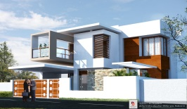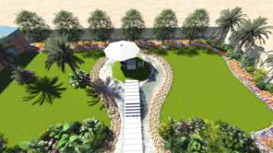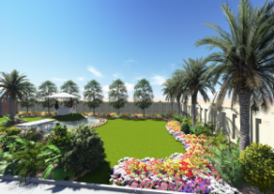

Date of Birth : 01-JUNE-1990

Gender : Male

Marital Status : Single

Nationality : Indian

Mother Tongue : **Tamil**

Known Languages : English, **Tamil**

# No Specific Geographical preferences can relocate for work.

**Personal Details**

**Work Samples**

**Technical Skills**

100% 0% 100%

**Autodesk AutoCAD**

**Adobe AfterEffects**

**Lumion 3D**

**Adobe Illustrator**

**Sweet home 3D**

**3D Studio Max**

**Adobe Premiere Pro**

**Blander 2.71**

**Adobe Photoshop**

**Combustion**