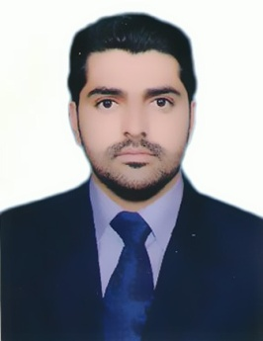

MUHAMMAD

MUHAMMAD.307084@2freemail.com

PERSONAL DETAILS:

- Profession: Electrical Engineer
- Status: employment visa
- DOB: 24/04/1990
- Location: Dubai
- Nationality: Pakistani

PERSONAL SUMMARY:

A highly efficient, hardworking and talented electrical engineer with a comprehensive understanding of design processes and also manufacturing and construction methods. Possessing a good team spirit, deadline orientated to find a challenging & suitable engineering position with an ambitious company that offers opportunities for career development and advancement.

ACADEMIC QUALIFICATIONS

- BS (HONS) ELECTRICAL TECHNOLOGY(CGPA 3.1) from UNIVERSITY OF GUJRAT (PK).(attested from UAE Embassy)
- 3 years diploma of ASSOCIATE ENGINEER in ELECTRONICS from PUNJAB BOARD OF TECHNICAL EDUCATION.

EXEPERCINCE

- Currently working in SHAHZAD ALI AND MAZHAR IQBAL TECHNICAL AND MAINTENACE SERVICES LLC. As a GENERAL ELECTRICAL ENGINEER.
- Worked as a DATA ANALYSIS in Marie Stopes International (UK) Gujrat (Pk) center JAN 2017 To Sept 2017
- 1 years working experience as a TRAINE ENGINEER in ALBARKAT SOLAR CO.

AREAS OF EXPERTISE

- Supervision OF ELECTRICAL SYSTEM
- Design concepts.
- Building line Electrical System
- Solar System and CCTV installation
- Control Panel

TECHNICAL KEY SKILLS AND COMPETENCIES

- Comprehensive understanding of Engineeringand Design Principles.
- PLC Programming SiemenS7-200 System
- Understanding of computer-assisted design software and MS Office software .

SHORT COURSE

- 3 month Diploma of PLC system (Beginner).
- Three month diploma in Computer Hardware/Software.
- Three month diploma in Low Voltage Electrical System.
- E draws Max electrical wiring planning.
TECHNICAL TRAINING
- 6th month Youth Internship Training under Gujrat Chamber of Commerce and Industry.
- 3 days data analysis training in Marie Stopes Org (UK) Lahore.

AWARDS

- Participation award in SPEED WIRING by ELEX University OfGujrat.
- Participation award in LOGIC HUNT by ELEX University OfGujrat.
- Participation award in All Pakistan Project and Poster Competition University of Gujrat.

PERSONAL SKILLS

- Generating new Ideas
- Relationship Building

(Expected salary 3500 AED)

