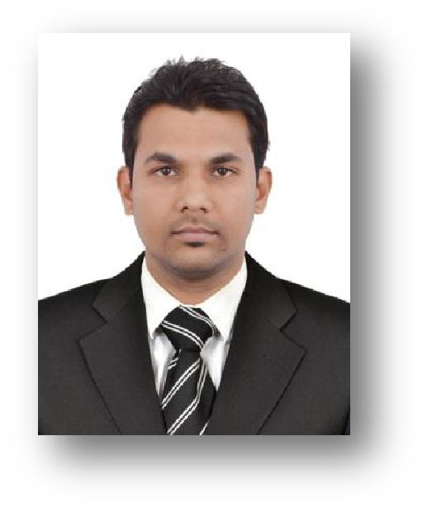
Sriram

2.5 Year Experience Dubai + 2 Year

Sriram.307373@2freemail.com

Heriot Watt University Dubai Campus

DOB: 17.04.1990 | INDIAN | SINGLE

Ready to Join Immediately

Personal statement

Highly reliable and focused Management Student with good record of exemplary work experience. Able to work independently with little to no supervision or as a team member. Adept at maintaining and updating multiple tasks in marketing management.

Summary of Qualification

- Acquired efficient work experience for 4 years in management and marketing sector. Incurred good international work experience.

- Familiarity to work with computer; Microsoft Excel, PowerPoint, Word.
- Business management with efficiency.

- Ability to understand management concerns and employee concerns and handle both sides with clarity and efficiency.

- Strong decision making skill set.
- Good communication skills.
- Strong negotiating skills.

Education

Post Graduate in International Business Management

Heriot Watt University - Dubai. (September 2016)

University Research project 1:- Influence of social status in consumer purchase decision making. In this topic the research was made to analyse the perception of the people in purchasing products depending on their social status by conducting surveys to the target audience related to the supermarkets in UAE.

University research project 2:- The role of gender in consumer buying behaviour and its impact on their decision making process in banking sector of UAE. In this topic the

research was made to analyse the influence of gender in consumer buying decisions by conducting survey, by adopting quantitative approach method related to the target audience of banking sector in UAE.

University research project 3:- Evaluating teaching quality in higher education

universities of Dubai from students’ perspective. In this topic the research was made to analyse the teaching quality of both domestic and foreign universities located in Dubai by adopting quantitative approach method. The survey was conducted to the students of each university to obtain efficient data related to the education sector of Dubai.

Bachelor Degree in Commerce

Amrita University, Mysore. (September 2014)

Employment History

Happeners Sports Academy, Bangalore

(Jan. 2018 to June 2018) Administrative Executive

- Implements plans

- Manages human resources of organization

- Manages financial and physical resources

Marketing and management department

January 2017- June 2017

Way to Success Training Institute, Dubai, UAE.

- Managing marketing, advertising, promotions and arranging communication programs to increase brand awareness.

- Undertaking detailed ongoing analysis of marketing campaigns to ensure targets are met.

- Understanding the product and customer profile to fulfil the requirements of customers.

Marketing Executive

January 2016- January 2017

New link businessman services, Dubai, UAE.

- Develop and maintain long- term relationships with marketing associations and advisors.

- Create and implement marketing plans including promotions, media, mailings, and special events.

- Manage all aspects of marketing planning, budgeting, metrics and reporting.

Marketing Executive- S.R Enterprises, Telesales Executive-Sabre marketing services private limited in Bangalore, India.

(June 2008 – January 2011)

Achievements and responsibilities:

- Handling client relationships.

- Evaluating new business potentials.

- Entailing in meeting clients on a daily basis.

- Evaluating the customers concerns and consolidating their feedback.

- Presenting new options for the preferred client.

- Ensuring client satisfaction and bring in repeated business.

- Preparing management reports and identifying appropriate market opportunities.

- Analyse all business objectives and ensure achievement of product mix for all relationships with customers.

Hobbies & Interests

I was involved in a local amateur story writing society, where the members had to write creative stories which would be considered for the short film making process. I worked with a promotion team for many products in and around Bangalore. I have been involved with this team for three years and very much enjoys being a part of the team. Towards the end, I assumed the role of team leader for a two week promotion of Tally and relished the chance to take control of the events.

Languages Known

• | English | (Fluent)
• | Hindi | (Fluent)
• | Tamil | (Fluent)
• | Arabic | (Beginner)
• | Malayalam | (Fluent)
• | Kannada | (Fluent)

References

References are available upon request.

