URRICULUM

OBJECTIVE:
Iqra _
307521@gulfjobseekers.com

To fill a challenging position in the organization with a diligent environment utilizing my knowledge and experience to ascend myself towards a better future.

PERSONAL DETAILS:

Date ofBirth 18-05-1991
Gender Female Nationality Pakistani Religion Islam

EDUCATION
•t• It is fully professional degree, which covers the business, education and health fields, the education is under highly qualified professionals, teachers and the emphasis is on the practical work.

ACADEMIC PROFILE:

DEGREE SUBJECTS

Division I
Grade
- -
BOARD I UNIVERSITY

M.Phill
Medical Micro 1st Cont. Biology

GCUF

BHMS Medical st
1
F.Sc Pre-Medical nd
2

I I.U.B
I Federal Board

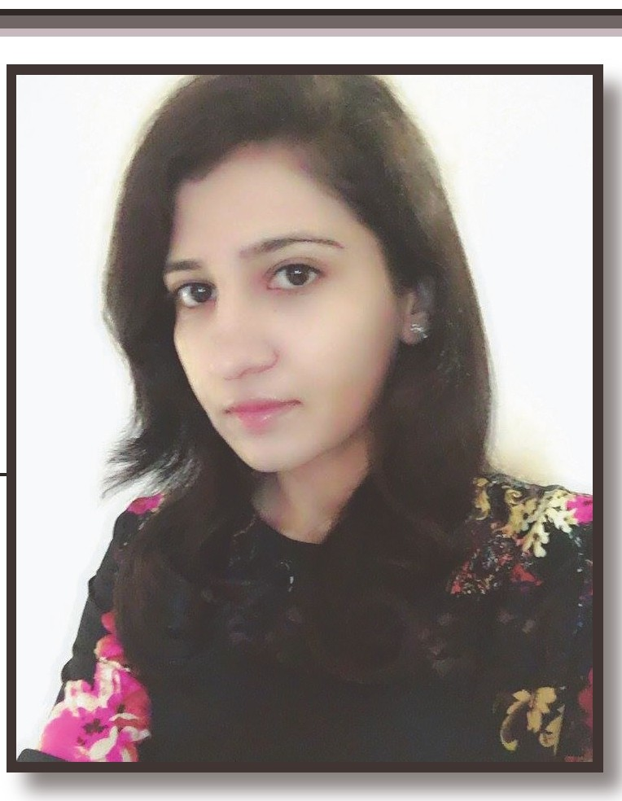Matriculation Science 2nd Gujranwala Board

MAJOR SUBJECT:

•!• Physiology, biochemistry, human anatomy
•!• Microbiology, pathology, surgery, pediatrics, community medicine
•!• Obstetrics and gynecology, psychology, ophthalmology and ENT
•!• Bioinformatics (minor)
•!• Clinical diagnostics, therapeutics, pharmacognosy, pharmacy,

BIODATA
Nam of the post Applied: Category:
Sub Category:
Highest qualification attained:

•:• Major/Specialization:
CERTIFICATES:

Homeopathic Physician
Medical
BHMSDoctor
B.H.M.S/BHMS Bachelor of Homeopathic
Medicine and Surgery
Homeopathic Medicine and Surgery.

+ Workshop by American society for microbiology at GCUF.
Certificate of registration as Homeopathic medical practitioner.
•:• Certificate of MCPS in family medicine from university of health sciences Lahore
(FMH).
SKILLS:
+ Ability to teach all basic medical subjects like physiology, biochemistry and microbiology.
• General physician
• Research Article and research work on H pylori.
• Separation of components by thin layer chromatography.
• Isolation and purification of Bactria and fungi.
• Operating of microbiology lab instruments.
• Computer skills (MS word, Power Point, and Working knowledge of the internet)
• Good filling and organizational skills.
• Well know about statistical package for social science (SPSS) software.
• Project and research proposal writing
• Gynaecology problems.
EXPERIENCE:
+ HouseJob.
•:• Medical officer in Anwar Fatima hospital for 1 year in M.B. Din
PERSONAL TRAITs:
+ Clean, honest and dedicated person. Responsible and reliable. Energetic even difficult situations have positive attitude and optimistic style of thinking.

INTEREST:
Research
<• Teaching
+ Clinic
OTHER WORK:
<• Marketing Management

LANGUAGE:
•:• English, Urdu, Punjabi

