Resume

Click to send CV No & get contact details of candidate
CV No: 1846416
RRAM
HAHZAD

To seek challenging position in an organization with an aim to contribute positively towards its objectives to the best knowledge abilities and skills and to serve with honestly integrity and diligence with the firm belief that the entity growth and success would be my own.

liRSOllAt. lttFIIRI4ATl£tlt
é Date of Birth 15-09-1991
Gender Male
é Marital Status Single
Religion Islam
Nationality Pakistani

ACADEMIC & PROFESSIONAL QUALIFICATION

é Diploma of Hotel Management TDCP institute of Tourism
and Tourism 2014-2015 and Hotel Management Rawalpindi.
Graduation University of Punjab 2012-2014 I Inter Rawalpindi Board 2009-2011
Matric Rawalpindi Board 2007-2009

COh4PUTER SKII.I.h

- Basic Computer. MS Office, Internet, Email.

Experience
- Working in Noor Al Ardh Technical services L.L.C. Dubai as an Office Assistant.
•l• 01 Month internship at Marriot Hotel Islamabad.
•l• Training in Cambridge institute having accent naturalization, communication Skills
Training, Convincing power, Call Center training at Islamabad.

CERTIFI€’ATION h

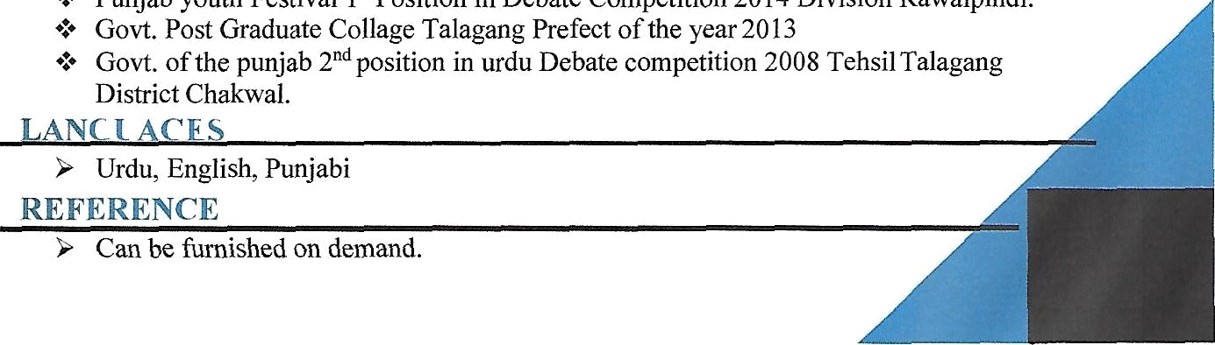
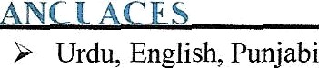
•l• Punjab youth Festival 1" Position in Debate Competition 2014 Division Rawalpindi.
- Govt. Post Graduate Collage Talagang Prefect of the year 2013
•l• Govt. of the punjab 2 d position in urdu Debate competition 2008 Tehsil Talagang
District Chakwal.

