CURRICULUM VITAE
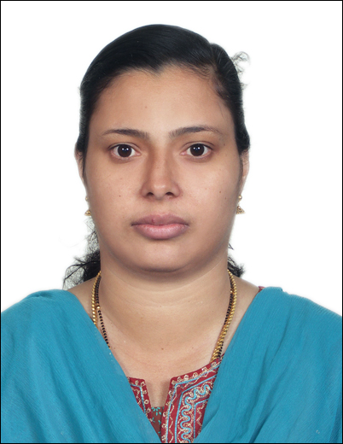
MANJIMA
MANJIMA.307971@2freemail.com

PERSONAL SUMMARY
An energetic and versatile tutor able to teach across a wide range of Computer and IT topics. I Manjima come to you with a strong background in planning lessons, organizing extra-curricular activities and helping to transform the lives of my pupils and possess a variety of competencies that set me apart from other candidates, chief amongst these is my ability to not only get students to listen, but to also understand. As a seasoned professional I can turn best practices into high quality, goal-driven results. Aside from my technical competencies, my pleasant manner and excellent communication skills allow me to quickly connect with children from all social backgrounds. At the moment I am looking for a suitable position with a school that has a culture that appreciates and rewards excellence.
CAREER HISTORY
COMPUTER SCIENCE TEACHER – April 2014 - present
Employers name – Shining Star International School, Mussafah, Abu Dhabi
Responsible for teaching a computer curriculum that is consistent with the schools district goals and objectives.
Duties:
- Teaching all areas of the school computer curriculum.
- Teaching students the latest computer skills.
- Creating rigorous lessons that are aligned with the subject curriculum.
- Providing ongoing and timely feedback to students on their progress.
- Involving parents and careers in a child’s education.
- Completing daily pupil attendance reports.
- Preparing assignments, course material and lessons for pupils to do.
- Marking and grading a pupil’s class and home work.
- Demonstrating computer hardware and software to students.
- Encouraging classroom discussions between pupil’s.
- Informing parents of a student’s academic progress.

- Installing teaching software on computers.
- Selecting which teaching resources to use in class.
- Enforcing high standards of student behaviour.
- Working closely with other teaching and school staff.
- Maintaining discipline in the classroom.
- Attending parents' evenings.
- Attending staff meetings.
- Researching new subject topic areas to teach.
- Proficient in Windows and Microsoft Office software.
- Conducting frequent and appropriate assessments of a student’s abilities.
EDUCATION:
Academic Qualification: • Graduation in Zoology (BSc) as Main subject and Chemistry &
Botany as Subsidiary subjects, from SN College, Kannur,
Calicut University, Kerala.
Professional Qualification: • Post Graduate Diploma in Computer Applications From
Model Poly, Vatakara, Kozhikode, Kerala (Institute of Human
Resource Development)
- CO&PA (Computer Operator and Programming Assistant) NCVT from Airconds Computer center &ITC, Vatakara, Kerala
- English Typewriting – LOWER GRADE (Kerala Government Technical Education Department)

EXPERIENCE IN OVERSEAS
Sl.No. | Institution’s Name | From | To | Remarks
 |  |  |  | Subject Taught | Classes Taught
1 | Indian Islahi Islamic School, Abu Dhabi | 10/4/2008 | 31/3/2014 | Computer Science | Grade V – X
2 | Shining Star International School, Abu Dhabi | 1/4/2014 | Present | Computer Science | Grade V – X
 | Total No.of years of Experience | 7 years

EXPERIENCE IN INDIA

Sl.No. | Institution’s Name | From | To | Subject Taught | Classes Taught
1 | Amritha Vidhiyalayam, Vatakara,Kearala | 2/6/2006 | 31/3/2008 | Computer Science |  | Grade I - IX
 | Total No.of years of Experience | 2 years

LICENSE
- Teaching License issued from ADEC
KEY SKILLS AND COMPETENCIES
Professional
- Operational knowledge of the Internet and web-related technologies.
- Maintaining order in the classroom in a fair and just manner.
- Maximizing time on task.
- Accepting responsibility for her own actions.
- Extensive web and internet experience.
- Working with other teachers in a collaborative, productive, and supportive manner.
- Preparing in detail for up-coming lessons during the school day.
- Treating all pupils in a respectful manner.
- In-depth understanding of all subject matter.
Personal
- History of producing significant student learning gains.
- Have a relaxed attitude and a friendly personality.
AREAS OF EXPERTISE
Classroom Management
Teaching Skills

Declaration
I hereby declare that all the information given above is true to the best of my Knowledge and belief.

