Curriculum Vitae Mehrdad

PERSONAL INFORMATION Mehrdad
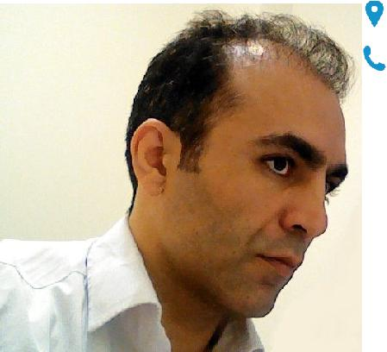

​Email: mehrdad.308096@2freemail.com

Sex​Male​​|​ Date of birth​22/09/1977​​|​ Nationality​Iranian​​| Marital Status Single​

JOB APPLIED FOR POSITION

WORK EXPERIENCE ( 2011 ­ 2016 )

Programming or related to IT

Managing Director

Moj Software Development and Design Consulting Group Co ( Register Number : 443120 ) Ferdowsi square / Tehran / Iran
▪ Managing all media for producing educational software Business or sector​Software​ ­ Education

( 2008 ­ 2010 ) Developer

West Processors Co ( Mosadegh Street ­ Kermanshah ­ Iran )

▪ Design & Coding Web & Desktop Applications Business or sector​Software​

( 2000 ­ 2004 ) Technician

Farhangian Computer Center ( Mirdamad Mall / Kermanshah / Iran )

▪ Assemble computers & pieces ­ Simple repairment & Error Correction ­ Establishing Small networks for Schools & Coffee­nets
Business or sector​Software​ ­ Hardware Network

​www.karpira.noooa.com Page​1​/ 3

 | Curriculum Vitae | Mehrdad
EDUCATION
( 2012 ­ 2015 ) | Information Technology Engineering Major Data Security | GPA : 15.30
 | Applied Science & Technology ( Arak / Iran )
( 2004 ­ 2007 ) | Computer Science Major Software | GPA : 16.16
 | Islamic Azad University ( Arak / Iran )
TRAINING
( 2012 ­ 2013 ) | Digital Publisher
 | Iran Informatic Center ( Tehran / Iran )
 | ▪ Publish Content on Digital Platforms
( 2004 ­ 2005 ) | Professional Computer Operator
 | Technical & Vocational Training Organisation ( Kermanshah / Iran )
( 2002 ­ 2003 ) | Computer Operator Grade One
 | Technical & Vocational Training Organisation ( Kermanshah / Iran )
( 1998 ­ 1999 ) | Computer Operator Grade Two
 | Technical & Vocational Training Organisation ( Kermanshah / Iran )

PERSONAL SKILLS

Mother tongue(s)

Other language(s)

English

Kurdish

Organisational / managerial skills

Computer skills

Persian
UNDERSTANDING |  | SPEAKING |  | WRITING
Listening | Reading | Spoken interaction | Spoken production
Fluent (c2) | Fluent (c2) | Fluent (c2) | Fluent (c2) | Intermediate (b2)
Intermediate(b2) | low(a1) | Intermediate(b2) | Intermediate(b2) | low(a1)

Managing all the media contents

▪ I was responsible for a team of 6 people

Coding with most common software programming languages ( Web ­ Desktop ­ Mobile )

​www.karpira.noooa.com Page​2​/ 3

Other skills

Driving licence

ADDITIONAL INFORMATION

Publications

Presentations

Projects
Curriculum Vitae Mehrdad

- Real Time Systems & Communications

- Familiar with : ccna ­ ccnp ­ ccie ­ mcitp ­ mcse

Driving licence category B

Way To Toefl ( training English on DVD )

More than 20 training DVD in several area : 2d & 3d design ­ animation ­ film editing network ­ coding and … .

First Iranian voip service

​www.karpira.noooa.com Page​3​/ 3

