Curriculum Vitae
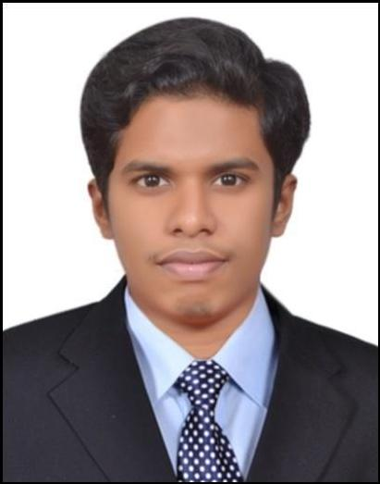

Fawzan

fawzan.308150@2freemail.com

Personal Details

AGE | : | 25 YEARS OLD.
DATE OF BIRTH | : | 1991-OCT-06.
MARITIAL STATUS | : | SINGLE.
GENDER | : | MALE.
NATIONALITY | : | SRILANKAN.
SCHOOL ATTENDED | : | ZAHIRA COLLEGE COLOMBO - 10 SRI LANKA.
VISA STATUS : Own Visa (Residence - Employment).

Job Profile

- BIT Bachelor of Information Technology with nearly seven years of experience in following industrial and corporate environment with hands on experience as,

- IT Manager / Administrator.
- Customer care service.
- Online social media management.
- Sales Executive cum Office administration.
- Quality assurance executive.

Working Experience

Sri Lanka

- Worked as IT Administrator in Mind4 Integrated Solution Advertising Firm. Colombo, Srilanka. (2009 Feb – 2012 Dec )

Duties and Responsibilities
- Maintaining Production, Art, Accounts, Management Unit’s Computers and data's.
- Hardware, Networking and Maintaining Network Environment.
- Troubleshooting Computers, Printers etc ...
- Responsible for Purchasing IT Products for Company.
- Office administration and paper works.

UAE - United Arab Emirates
- Worked for two companies as a Assistant administration manager cum IT manager in City Travel Point L.L.C and Zecco Commercial Brokers L.L.C. (2013 Jan - 2014 Jun)

Duties and Responsibilities
- Maintaining all Computers and data's of Companies.
- Responsible for Purchasing IT Products for Company.
- Networking and Maintaining Network Environment.
- Troubleshooting Computers, Printers etc ...
- Technical Support.
- Office admin works.
- Assistant management to entire unit of brokers and traders.

Sri Lanka - United Kingdom
- Worked for Inbay U.K United Kingdom London based company's global customer care center for a one year quality assurance and IT data audit project (2014 August - 2015 August)

- Level 1 Customer support executive.
- Handled L1 issue tickets.
- Hand on experience in Autotask.net.

United Arab Emirates

- worked for two companies as a Online social media manager / Executive of sales for Q - Mobiles UAE and Sofltlinks mobiles and computers. (2015 October - 2016 July)

Duties and Responsibilities
- Online social media official accounts management. ex- facebook / twitter / Google+ etc...
- Websites designs, websites management and updates.
- Online advertising and campaigns.
- Executive of sales team.

Personal Abilities and Skills

- Reliable and Responsible.

- Innovative and Able to Develop New Ideas.

- Able to Work as a Team or Individual.

- Convincing Skills with a Logical Mind.

- Strongly Committed to Assigned Task.

Academic Educational Qualifications

- BIT - Bachelor of Information Technology. SLIIT Srilanka.
Sri Lanka Institute of Information Technology.

- Passed G.C.E O/L (Ordinary Level) (2007).

- Passed G.C.E A/L (Advance Level) (2010). Zahira College Colombo Srilanka.

Professional Educational Qualifications
- MCTS - (Microsoft Certified Technology Specialist 70-680).
Turnkey IT Training. Bambalapitiya Colombo 03, Srilanka.

- MCITP – (Microsoft Certified IT Professional)
(Server Administration Windows server 2008 R2).
NLP Tech Institute. Bank Street Bur Dubai, UAE.
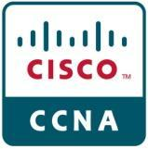
- CCNA (Cisco Certified Network Associate) Version 2.
NLP Tech Institute. Bank Street Bur Dubai, UAE.

- Higher Diploma in Access Program of Information Communication Technology in
BCAS. British College of Applied Studies. Wellawatte Colombo 06, Srilanka.

- Specialization in Computer Hardware Engineering and Network Engineering.
BCAS. British College of Applied Studies. Wellawatte Colombo 06, Srilanka

- Diploma in Industrial Training in Windows Network Administration.
Turnkey IT Training. Bambalapitiya Colombo 03, Srilanka.

Extra Curricular Activities

• Cub Scout - Junior Section Scout - Senior Section

Zahira College, Zahira College,

Colombo 10. Colombo 10.

- Organizer in Organizing Committee of 1st Annual International Research Symposium of Pioneer Institute of Business & Technology (PIBT) Colombo - Srilanka.

