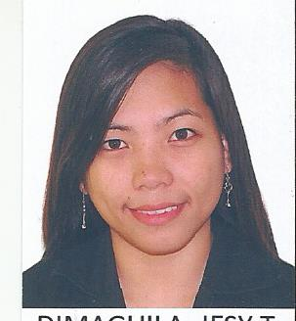
JESY T. DIMAGUILA, RCE

Click to send CV No & get contact details of candidate
CV NO: 1848930

OBJECTIVE: “To work in a company with extensive Goal and Highly Competence Organization wherein I can develop my knowledge and work performance helping throughout the company’s objective moving forward as a team toward the success of its organization.”

PERSONAL INFORMATION:

Date of Birth : October 21, 1991
Place of Birth : Cardona, Rizal
Civil Status : Single
Height : 5’0 ft
Weight : 125 lbs.
Citizenship : Filipino
Religion : Catholic
Language Spoken : English/Filipino

EDUCATIONAL ATTAINMENT:

Tertiary : UNIVERSITY OF RIZAL SYSTEM MORONG (URSM)
Course : Bachelor of Science in Civil Engineering
2008-2013

WORK EXPERIENCE:

ILJIN WALLTECH INC.
Position: ALUMINUM CURTAINWALLDESIGNER (DESIGN DEPT.) 2014 - 2016

PRIMARY DUTIES:

- Work preparation MTO, Shop Drawing, Job Material Listing, and Fabrication Drawing.
- Preparation of Architectural plans, Shop Drawing, Detail Plan, Interior Elevation, Bay Section, Area Computations, and Structural Drawings
- Quantity Estimate and Take-off
- Making sure that all material shall conform with the design drawing specifications, and reject the serviceability of such.
- Supervision and inspection of project through the various work stages
- Perform As-built Drawing and shop drawings for the revision of Structural / Architectural plan based on actual site condition

PROJECT INVOLVED : BURBERRY BLDG. KOREA, AQUA PEBBLE PHILLIPPINES, VANCOUVER HOUSE CANADA

QUALIFICATIONS

Qualification : Bachelor's/College Degree/Board Passer

License # :0132748

OTHER SKILLS

- Proficient in MS Office Applications (Word, Excel, Powerpoint)
- Communication Skills
- AutoCAD
- Able to work under time pressure and stress
- Creative, Team Player and Detail-oriented
- Good listener and positive thinker
- Strong ability and flexible

REFERENCES:

Available upon request.

I hereby certify that the foregoing statements made by me are true and correct to the best of my knowledge and belief.

____________________________
JESY T. DIMAGUILA

