MARWAN
Contact: C/o 0505891826 | Email: marwan.308241@2freemail.com

PROFILE SUMMARY
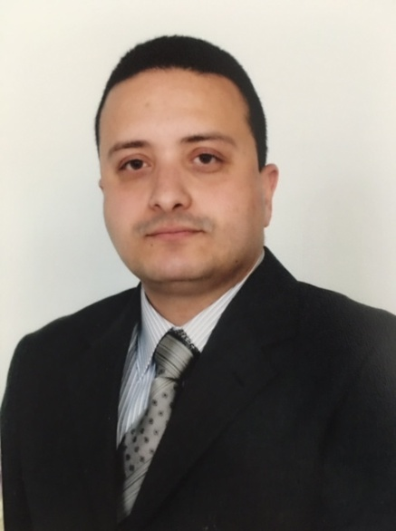
Articulate, courteous, dependable professional with around 16 years of experience. Profound know-how of greeting visitors, keeping the reception area clean and organized, providing customer service and updating records. Exceptionally well organized with a track record that demonstrates self-motivation, creativity and initiative to achieve both corporate and personal goals. Possess necessary skills to resolve customer complaints, handle high volume phone calls and answer customer queries.

Expert ability to lead project teams and translate employee development behaviour into high-impact learning designs, curriculum, tools, and workshops to create an internal knowledge transfer. Passionate, aggressive and confident trainer with logical, incisive and critical problem-solving capabilities. Proven expertise in improvising effective solutions to problems with hands on approach and effective resource deployment. Exceptionally well organized with a track record that demonstrates self-motivation, creativity and initiative to achieve both corporate and personal goals.

CORE COMPETENCIES

- Reception Area Management | - Hotel Cleanliness | - Guest Relationship Management
- Bill Processing | - Security Maintenance | - Correspondence Handling
- Issue Handling | - Issue Resolution | - Record Keeping
- Front Office Operations | - Facility Management | - Airport Operations Management

WORK EXPERIENCE

Hines Interests Real Estates (Since Nov 2012)
Front Office Manager

Significant Highlights:
- Meticulously made sure that all policies and procedures were adhered to during the shift in all relevant departments.
- Administered the completion of all Front Office administration and ensure quality standards were maintained.
- Displayed excellence in ensuring high quality customer satisfaction during guest services procedures for check-in, escorts, and badge assignments.

Key Deliverables:
- Participating in the selection of front office personnel. Preparing schedules for the front office staff and supervising workload during shifts.
- Evaluating the job performance of each front office employee. Maintaining working relationships and communicating with all departments.
- Verifying that accurate room status information are maintained and properly communicated. Resolving guest problems quickly, efficiently, and courteously.
- Conducting regularly scheduled meetings of front office personnel. Ensuring that employees are, at all times, attentive, friendly, helpful and courteous to all guests’ managers and other employees.
- Supervises daily activities, assisting in the supervision of Security Officers on assigned shift. Shouldering accountable to ensure proper execution of the assigned duties.

JR Services (Apr 2009 to Nov 2012)
Receptionist / Lobby Officer

Significant Highlights:
- Proved instrumental in serving as the first point of contact for all visitors and employees that enter the building.
- Actively offered protection services and patrolling of property. Efficient in performing interior and exterior patrols of the building inspecting all exits, alarm panels and emergency equipment.
- Successfully handled all emergencies as and when they arose. Proficiency to maintain a static position while working for extended hours.

Key Deliverables:
- Welcomed visitors by greeting them, in person or on the telephone and answered to queries. Directed visitors by maintaining employee and departmental directories.
- Adhered to security by following procedures, monitored logbook and issued visitor badges. Ensured to keep safe and clean reception area by complying with procedures, rules, and regulations.
- Maintained continuity among work teams by documenting and communicating actions, irregularities, and continuing needs.
- Ensured the neat of appearance of front office attendant as well as discussed problems that encountered on this point with front office manager, assistant front office manager and their shift leaders.
- Managed all security cameras and access control system (CCTV). Took pictures of employees for badges and programmed the badges for access into the buildings.

Iraqi Airways (Sep 2006 to Apr 2009)
Airport Operations Supervisor

Significant Highlights:
- Holds merit of establishing and maintaining effective working relationships with airport employees, tenants, representatives of other agencies and the general public.
- Successfully evaluated airport operations and security procedures and practices and develop plans to improve upon them.

Key Deliverables:
- Ensured that airport rules and regulations are enforced through the issuance of written and verbal admonishments.
- Planned, developed, implemented and coordinated security architecture and security systems for new as well as existing Airport and tenant facilities.
- Developed plans, procedures, measures and initiatives for implementation in consonance with federal regulatory requirements.
- Directed the diverse activities required to maintain the proper standard of airport operations. Evaluated situations quickly and objectively, and determine and implement a proper course of action.
- Determined compliance with prescribed operating and safety standards through observation, comparison and monitoring activities. Interpreted blueprints and plans, FAA, Egyptians rule and regulations.

EARLY CAREER

Royal Tulip Al Rasheed Hotel 5* (Sep 2003 to Sep 2006)
Guest Service Supervisor

Babylon Hotel 5* (Sep 2000 to Sep 2003)
Front Desk Agent

EDUCATION

2016 MBA / Human Resources Management, AIU
2015 Bachelors of Art / Business Administration, AIU

TECHNICAL PROFICIENCIES & TRAININGS
Technical Trainings: Opera, Oracle PeopleSoft HCM, SAP, Peek Pro, RMS, and ATA Translator (English-Arabic)
Proficient in various software programs and databases, including MS Office Suite.

PERSONAL DETAILS

Address: 6602 Ryan Hills CT Katy, TX, 77449
Languages Known: English and Arabic.
Nationality: US Citizen

